|  |  |  |
| --- | --- | --- |
| **شعار جامعة بنها الجديد**f |  |  |
| **Benha University** |  | **Faculty of Computers & Artificial Intelligence** |

**Covid-19 Challenge**

**(CC)**

A senior project submitted in partial fulfillment of the requirements for the degree of Bachelor of Computers and Artificial Intelligence.

**“****Computer Science” Program,**

***Project Team***

1. Ahmed Ayman Ahmed Ahmed
2. Amgad Saber Gaber Esmail
3. Bassam Mohamed Ghoneimy Elabassy
4. Eslam Ashraf Abdul-Razeq Hassan Elsawy
5. Hazem Moahmmed Abbas Sayed
6. Osama Mohammed Abdelfattah

***Under Supervision of***

**Dr. Rasha Orban** Benha, July 2022

DEDICATION

I dedicate this work

I would be very grateful if anyone could help me in writing my dedication letter, I would like to dedicate it to **my mum** and **dad**, how can I say it… who gives me inspiration of success and care throughout my life…

To my beloved family...

who always encourage me with endless passion and support.

To my faithful **brothers** and **sisters**...

Who always helped me and believed I could do this...

To my supervisor, **Dr. Rasha Orban**...

that spares nothing in my success...

Acknowledgment

It was a good opportunity to get an experience in computer vision applications development, and knowledge in how to design and develop a real project. So, at first, we decided to thank all the lecturers and the assistants who taught us how to learn or understand how to design and develop programs or even how to write programming codes for the great efforts they did in helping us. We would like to give a special thanks to our supervisor **Dr. Rasha Orban** because of her support, patience, and encouragement to get our project done. Her advice was great in helping us how to complete the project right. Also, we want to thank **Eng. Noha Abdelkareem** for her efforts, support, and encouragement. We would like to thank the faculty members of Computers and artificial intelligence.

DECLARATION

We hereby certify that this material, which we now submit for assessment on the program of study leading to the award of Bachelor of Computers and Artificial Intelligence in *(Computer Science Fourth year)* is entirely our own work, that we have exercised reasonable care to ensure that the work is original, and does not to the best of our knowledge breach any law of copyright, and has not been taken from the work of others save and to the extent that such work has been cited and acknowledged within the text of our work.

**Signed:** _____________________________

**Date:** Tuesday, 19 July 2022.

ABSTRACT

The novel Coronavirus has brought a new life in which social distancing and wearing face masks play a vital role in controlling the spread of the virus. But most people do not wear face masks in public, which increases the spread of viruses. This could lead to a serious problem of further spread. Hence to avoid such situations, we have to scrutinize and make people aware of wearing face masks. Humans cannot participate in this process, due to the chance of getting affected by corona. Hence the need for Artificial Intelligence (AI), which is the main theme of our project. Our project involves identifying people who wear face masks and who do not or improperly wear face masks in public places by using image processing techniques and artificial intelligence. Object detection algorithms are used to identify people who wear face masks and who do not or improperly wear face masks. We make use of OpenCV and Deep Learning to detect people from live camera, local video or images.

Table of Contents

List of figures iii

list of tables v

LIST OF ACRONYMS/ABBREVIATIONS vi

1 Introduction 1

1.1 Documentation Structure 2

2 Methodology 3

2.1 Introduction 3

2.2 Diagrams 3

2.2.1 Flowchart 3

2.2.2 Block diagram 4

2.2.3 Data Flow diagram 5

2.2.4 Context diagram 6

2.2.5 State diagram **Error! Bookmark not defined.**

2.2.6 Class diagram 8

3 System preparations 9

3.1 Introduction 9

3.2 Background 9

3.2.1 Computer Vision 9

3.2.2 Object Detection 10

3.2.3 Computer Vision Counting and Tracking 11

3.2.4 Computer Vision Image Segmentation 12

3.2.5 Detection Algorithms 13

3.2.5.1 YOLO 13

3.2.5.2 R-CNN 22

3.2.5.3 SSD 25

3.3 Motivation 30

3.4 Problem definition 30

3.5 Project objectives 30

3.6 Business Value 30

4 implementation 31

4.1 Introduction 31

4.2 Dataset 31

4.2.1 Dataset Meaning 31

4.2.2 Types of Datasets 31

4.2.3 Properties of Dataset 32

4.2.4 What Is a Dataset in ML and Why Is It Essential for Your AI Model? 32

4.2.5 What You Need to Know About Datasets in Machine Learning? 35

4..6 Dataset that has been prepared for our project 36

4.2.6.1 When do we use the dataset in the model to do training? 36

**4.2.6.1.1 Dataset collection 36**

**4.2.6.1.2 Dataset processing 37**

**4.2.6.1.3 Dataset splitting 38**

**4.2.6.1.4 Dataset extension type 38**

4.3 Used tools 39

4.3.1 Image Processing Library: Open CV 39

4.3.2 Editor: PyCharm 39

4.3.3 GUI Library: TKINTER 39

4.4 Imported Libraries 40

4.5 GUI main window components 40

4.6 Detecting Class 41

5 The proposed of application 44

5.1 Introduction 44

5.2 User interface 44

5.2.1 First scene 44

5.2.2 Open Web cam 45

5.2.3 Open Image 45

5.2.4 Open Video 46

5.3 Testing of the application 47

5.3.1 First Testing: Select Web Cam 47

5.3.2 Second Testing: Select Image 48

5.3.3 Third Testing: Select Video 59

6 conclusion 50

6.1 Introduction 50

7 Future work 51

7.1 Introduction 51

8 citation and referencing 52

8.1 Introduction 52

8.2 References to Electronic Sources 52

List of figures

Figure ‎1‑1: Flow chart. 3

Figure ‎1‑2: Block diagram. 4

Figure ‎1‑3: Data flow diagram. 5

Figure ‎1‑4: Context diagram. 6

Figure ‎1‑5: State diagram. 7

Figure ‎1‑6: Class diagram. 8

Figure ‎1‑7: Computer Vision. 9

Figure ‎1‑8: Object Detection. 10

Figure ‎1‑9: Computer Vision Counting and Tracking. 11

Figure ‎1‑10: Computer Vision Image Segmentation. 12

Figure ‎1‑11: The YOLO Detection System. Processing images with YOLO is simple and straightforward. 14

Figure ‎1‑12: Qualitative Results. YOLO running on sample artwork and natural images from the internet. It is mostly accurate although it does think one person is an airplane. 15

Figure ‎1‑13: The Model. Our system models detection as a regression problem. It divides the image into an S×S grid and for each grid cell predicts B bounding boxes, confidence for those boxes, and C class probabilities. 17

Figure ‎1‑14: The Architecture. Our detection network has 24 convolutional layers followed by 2 fully connected layers. Alternating 1×1 convolutional layers reduce the features space from preceding layers. 1**Error! Bookmark not defined.**

Figure ‎1‑15: Rectified linear unit activation 19

Figure ‎1‑16: How R-CNN works. 22

Figure ‎1‑17: Efficient of SSD. 26

Figure ‎1‑18: Layers of SSD. 27

Figure ‎1‑19: Divide the dataset. 33

Figure ‎1‑20: Dataset from Kaggle. 36

Figure ‎1‑21: Bounding box by Roboflow. 37

Figure ‎1‑22: Splitting dataset by Roboflow. 38

Figure ‎1‑23: Extension selection to dataset by Roboflow. 3**Error! Bookmark not defined.**

Figure ‎1‑24: Imported Libraries. 40

Figure ‎1‑25: Main Form Class initialization. 40

Figure ‎1‑26: Method from Main Form Class. 40

Figure ‎1‑27: Detecting Class Initialization. 41

Figure ‎1‑28: Image Method from Detecting Class. 41

Figure ‎1‑29: Video Method from Detecting Class. 42

Figure ‎1‑30: Real-Time Camera Method from Detecting Class. 43

Figure ‎1‑31: Start of the execution. 43

Figure ‎1‑32: First scene of the app 44

Figure ‎1‑33: Choose an image. 45

Figure ‎1‑34: Choose a video. 46

Figure ‎1‑35: Webcam real-time. 47

Figure ‎1‑36: Image with-mask, without-mask, incorrect-mask. 48

Figure ‎1‑37: Video with-mask, without-mask, incorrect-mask. 49

list of tables

Table ‎1‑1: Comparing R-CNN, Fast R-CNN and Faster R-CNN. 24

Table ‎1‑2: The table given below gives the details about all the operations in the SSD head. 28

Table ‎1‑3: Performance comparison with other models. 29

LIST OF ACRONYMS/ABBREVIATIONS

|  |  |
| --- | --- |
| AI  API  CNN  DPM  FMD  IOU  mAP  R-CNN  SSD  SVM | Artificial Intelligence  Application Programming Interface  Convolutional Neural Network  Deformable part-based model  Face Mask Detection  Intersection over union  Mean Average Precision  Region-based Convolutional Neural Network  Single Shot Detector  Support Vector Machines |
| YOLO | You Only Live Once |

Chapter One

# Introduction

The novel coronavirus covid-19 had brought a new life. The world was struggling to get out of this virus attack and the governments implemented lockdown for the long way. Lockdown placed pressure on the global economy. So, the government gave relaxations in lockdown. The world health organization declared that maintaining distance and wearing a mask is mandatory. The biggest support that the government needs after relaxation is social distancing and the wearing of masks by the people. But many people are getting out without a face mask which may increase the spread of corvid-19. Egyptian Ministry of Health has stated that “Survey Shows that 90percent Egyptians are aware, but only 44 percent wearing a mask ". This survey clearly points out that people are aware but they are not wearing the mask due to some discomfort in wearing and carelessness. This may result in the easy spreading of covid-19 in public places. The WHO has clearly stated that until vaccines are found the wearing of masks and social distancing are key tools to reduce the spread of the virus. So, it is important to make people wear masks in public places. In densely populated regions it is difﬁcult to ﬁnd the persons not wearing the face mask and warn them. Hence, we are using image processing techniques and deep learning to identify persons who wear face masks and who do not or improperly wear face masks.

## documentation structure

This part of the introduction deals with the chapters of the documentation, which are as follows: **Chapter 2** (Methodology): This chapter describes in depth how every aspect of the project was done, compiled, or created. Techniques, questionnaires, interviews, study sites, and material used to accomplish the study should be described here, **Chapter 3** (System Preparations): In this chapter, we discuss our preparations to confront the problem of Corona, but in a programmatic nature and the use of artificial intelligence to solve the problem by defining it, and then the objectives of the project in order to solve the problem ,**Chapter 4** (Implementation): Discuss the dataset ,used tools source code and show the output of the application, **Chapter 5** (The Proposed Application): Discuss The user interface and show the testing of the application, The desktop application has three options, you can open the webcam to detect the face mask in a live way, or you can select a picture from your device and send it to the application, and the application detect the face mask, or you can select a video from your device and enter it into the application, and the application detect the face mask as well, **Chapter 6** (Conclusion): Conclusions are presented to validate both the need for the study and explain how the present study solved the problem stated, **Chapter 7** (Future Work):Improvements that can be added in the future to the system, **Chapter 8** (References): Show references that we use to do our application.

Chapter Two

# Methodology

## Introduction

This chapter describes in depth how every aspect of the project was done, compiled, or created. Techniques, questionnaires, interviews, study sites, and material used to accomplish the study should be described here.

## Diagrams

Diagrams is a graphic design that explains rather than represents especially: a drawing that shows arrangement and relations (as of parts).

### Flow Chart

A diagram that depicts the processes of the project.

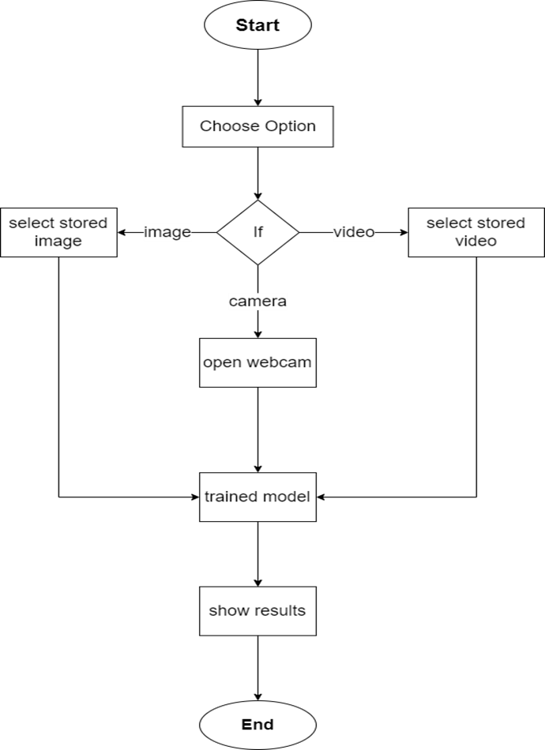

**Figure 1.1 (Flow chart)**

### Block diagram

A diagram of the project in which the principal parts or functions are represented by blocks connected by lines that show the relationships of the blocks.

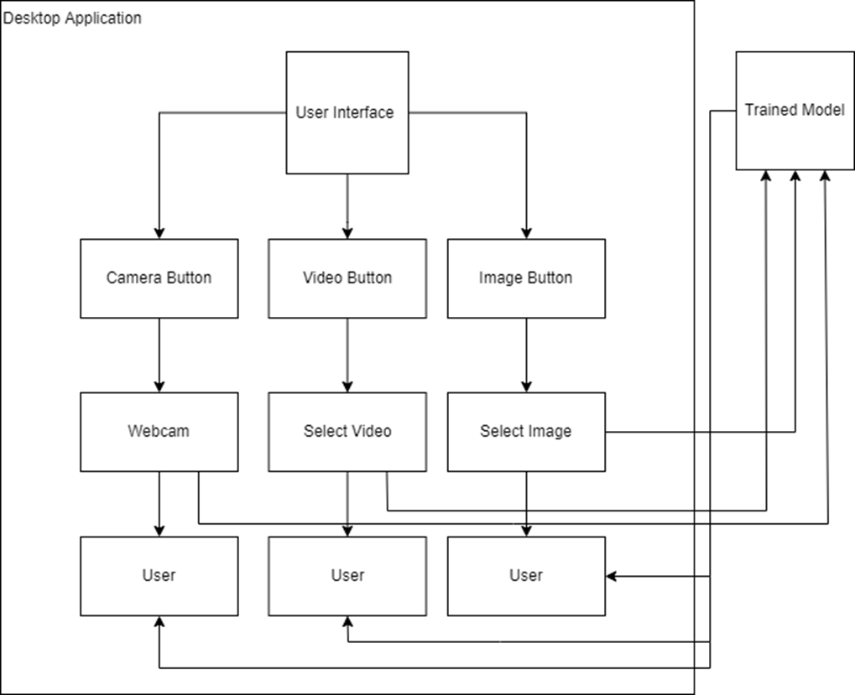

**Figure 1.**2 **(Block diagram)**

### Data flow diagram

A diagram that maps out the flow of information for the processes of the project.

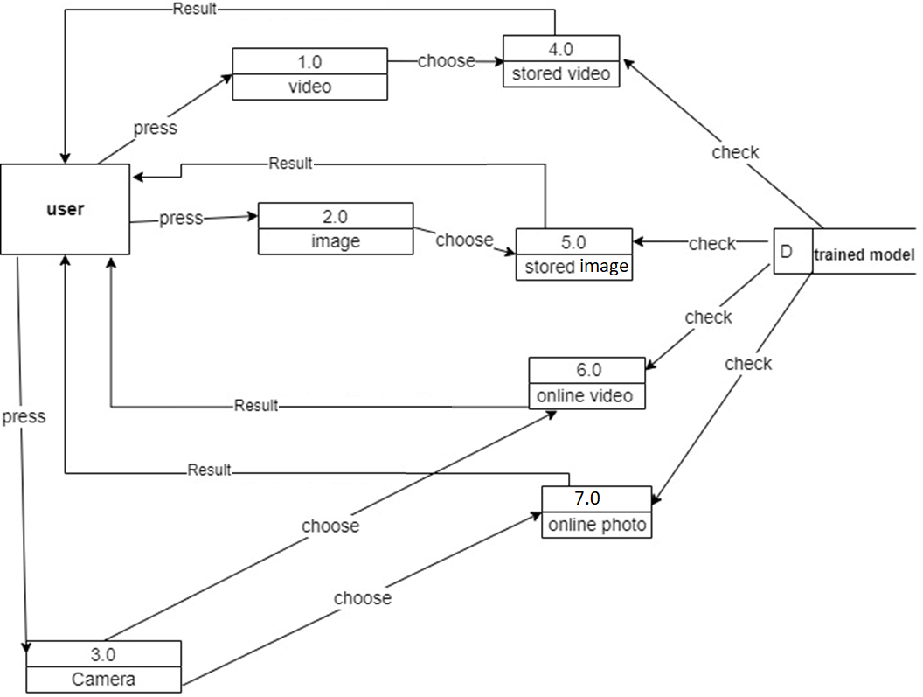

**Figure 1.3 (Data flow diagram)**

### Context diagram

A diagram that used to establish the context and boundaries of the project to be modelled, and what is the relationship of the project with these external entities.

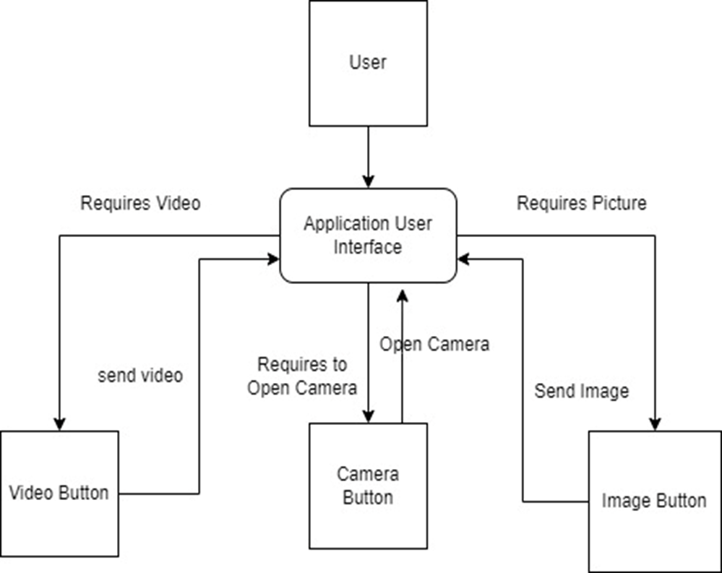

**Figure 1.4 (Context diagram)**

### State diagram

A diagram that used for describing the behaviour of the project.

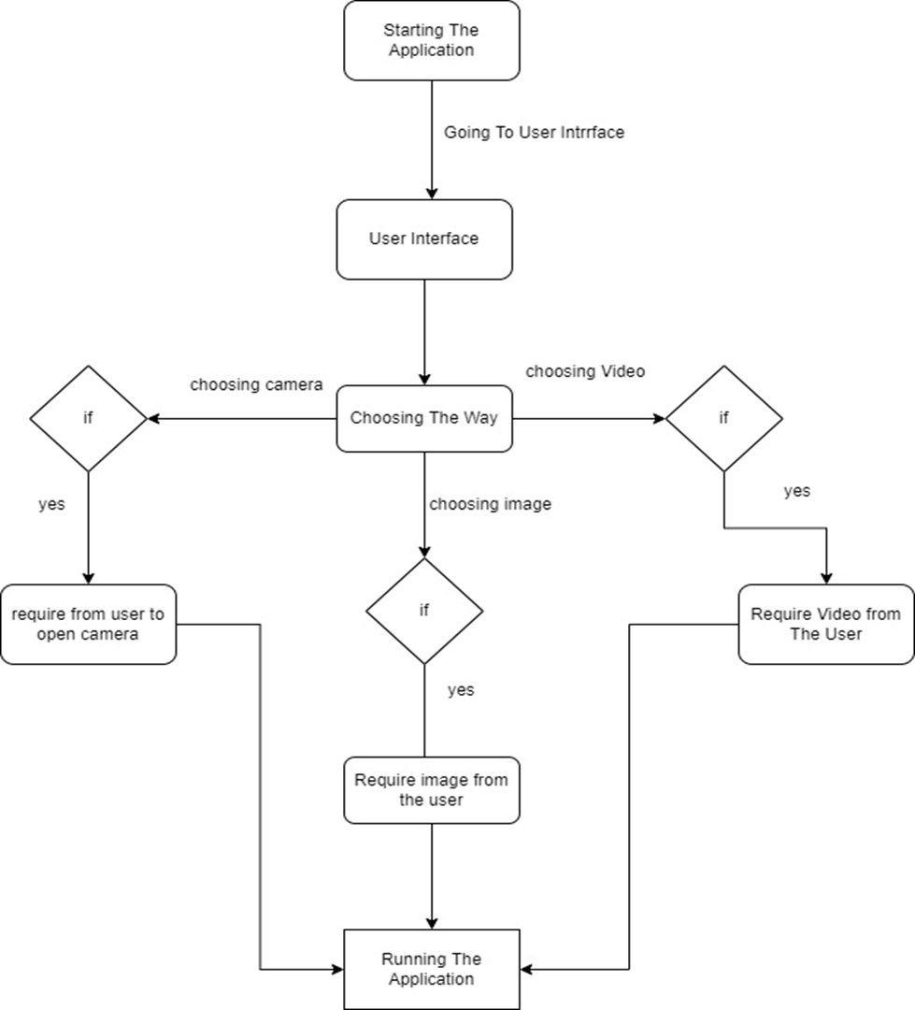

**Figure 1.5 (State diagram)**

### Class diagram

A diagram that used for describing the Classes in the project.

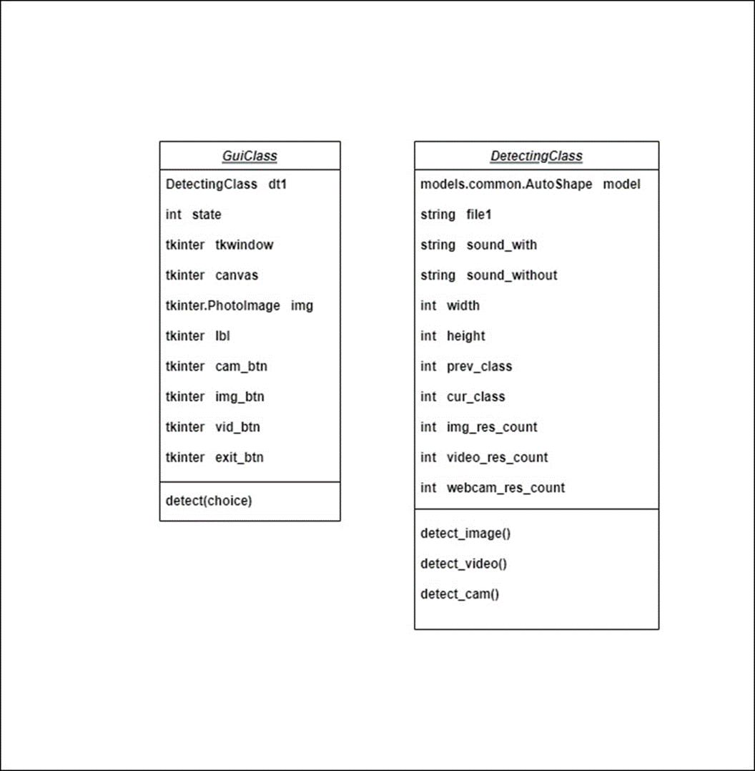

**Figure 1.6 (Class diagram)**

Chapter Three

# system preparations

## Introduction

In this chapter, we discuss our preparations to confront the problem of Corona, but in a programmatic nature and the use of artificial intelligence to solve the problem by defining it, and then the objectives of the project in order to solve the problem.

## Background

This section contains a general view of the model’s concepts.

### Computer Vision

You can create and deploy machine learning applications with Object Detection.

You can do this in four easy steps:

**1. Choose a model or train your own:** Train a custom model using our Model Training Toolkit or select one of the pre-trained models from the Model Catalog.

**2. Develop your app:** Use our flexible and customizable APIs to quickly enable core Computer Vision services such as Object Detection, Pose Estimation, Image Classification and Semantic Segmentation.

**3. Deploy to the Edge:** test and iterate with camera.

**4. Real-time Analytics:** Run the app and gain real-time analytics about what's happening.

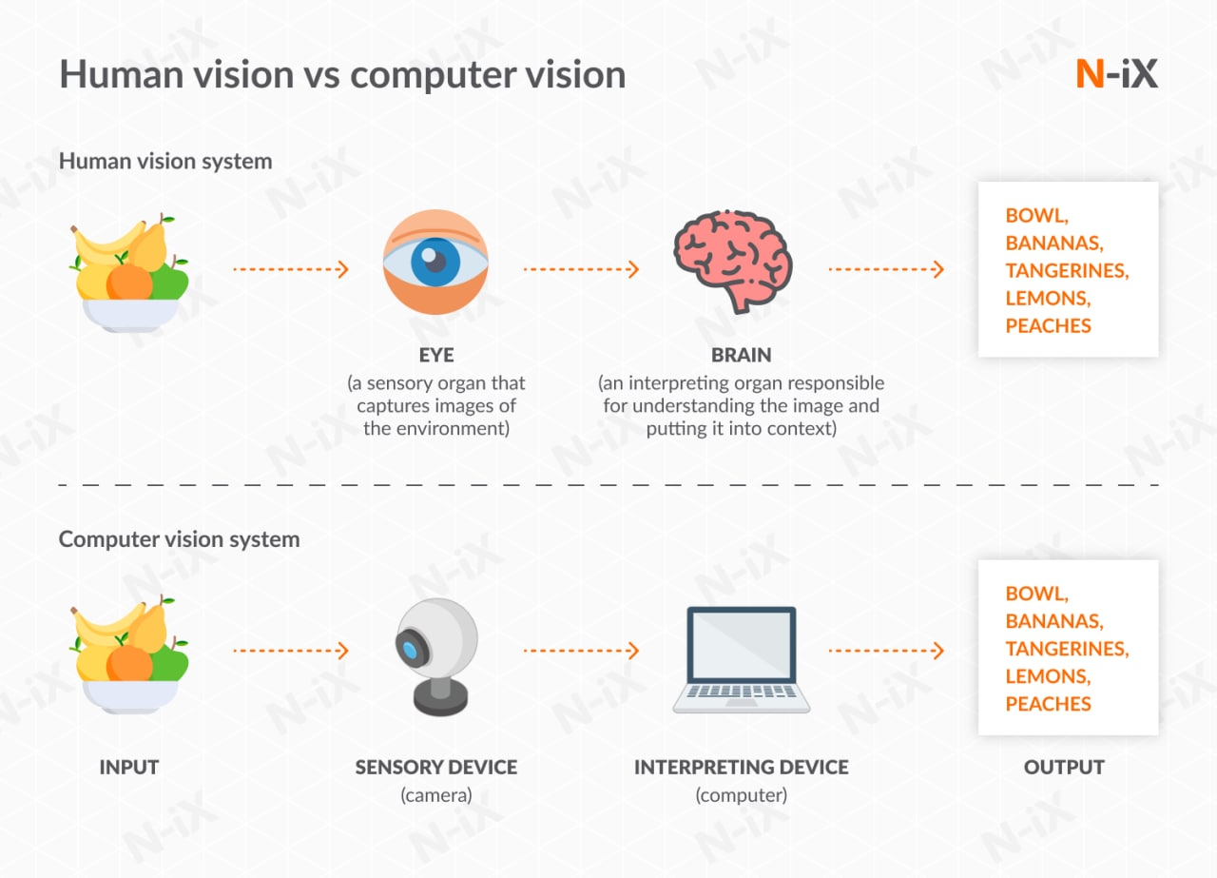 **Figure 1.7 (Computer Vision)**

### Object Detection

The simplest CV task – find objects in images and videos. Specify what you want to see, and we’ll make you a model. Simple.

This is also the basis of most other model types, that identify a thing, and also tell you something about what it’s doing.

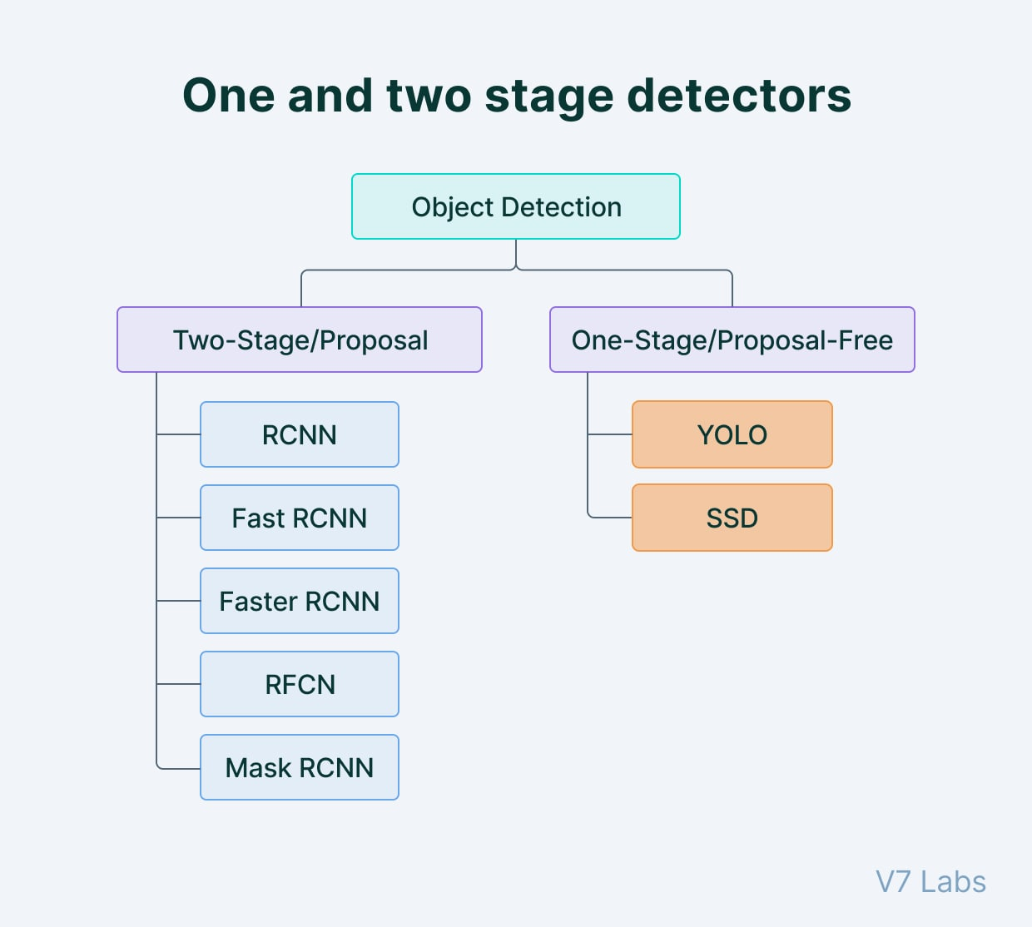**Figure 1.8 (Object Detection)**

### Computer Vision Counting and Tracking

What if you want to know how many people walked past your store today, but you don’t want someone walking back and forth all day to be counted multiple times? You need our Counting and Tracking algorithm.

Cars, animals, robots – tell us what you’re looking for and we’ll make a system to tell you how many there were, and where they all went. The numbers are next to the objects.

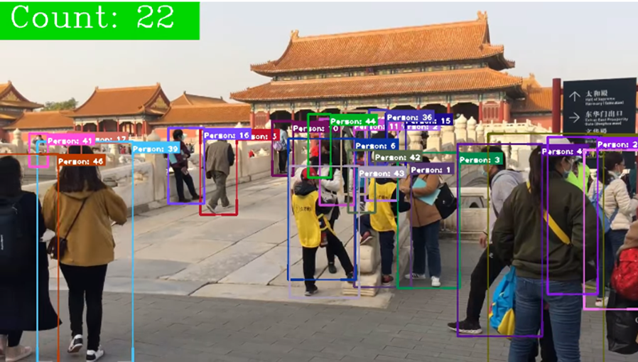 **Figure 1.9 (Computer Vision Counting and Tracking)**

### Computer Vision Image Segmentation

Need exact outlines for your objects, rather than boxes? A segmentation algorithm goes over every pixel and specifies which object it belongs to. Great for collision detection.

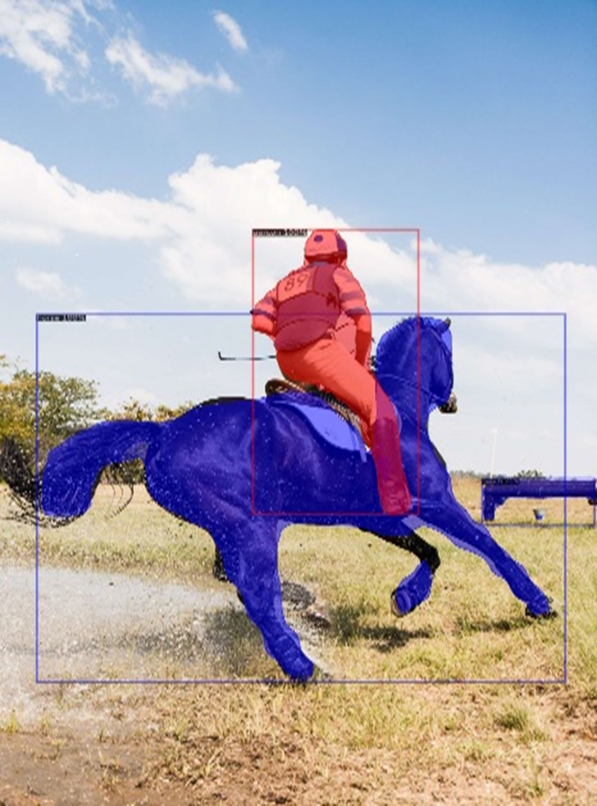

**Figure 1.10 (Computer Vision Image Segmentation)**

### Detection Algorithms

Computer technologies related to computer vision and image processing that deals with detecting instances of semantic objects of a certain class (such as humans, buildings, or cars) in digital images and videos.

### YOLO

YOLO is an algorithm that uses neural networks to provide real-time object detection. This algorithm is popular because of its speed and accuracy. It has been used in various applications to detect traffic signals, people, parking meters, and animals.

* **What is YOLO?** (Abstract)

YOLO, a new approach to object detection. Prior work on object detection repurposes classifiers to perform detection. Instead, we frame object detection as a regression problem to spatially separated bounding boxes and associated class probabilities. A single neural network predicts bounding boxes and class probabilities directly from full images in one evaluation. Since the whole detection pipeline is a single network, it can be optimized end-to-end directly on detection performance.

YOLO unified architecture is extremely fast. The base YOLO model processes images in real-time at 45 frames per second. A smaller version of the network, Fast YOLO, processes an astounding 155 frames per second while still achieving double the mAP (Mean Average Precision) of other real-time detectors. Compared to state-of-the-art detection systems, YOLO makes more localization errors but is less likely to predict false positives on background. Finally, YOLO learns very general representations of objects. It outperforms other detection methods, including DPM and R-CNN, when generalizing from natural images to other domains like artwork.

* **Introduction to YOLO**

Humans glance at an image and instantly know what objects are in the image, where they are, and how they interact. The human visual system is fast and accurate, allowing us to perform complex tasks like driving with little conscious thought. Fast, accurate algorithms for object detection would allow computers to drive cars without specialized sensors, enable assistive devices to convey real-time scene information to human users, and unlock the potential for general purpose, responsive robotic systems.

Current detection systems repurpose classifiers to perform detection. To detect an object, these systems take a classifier for that object and evaluate it at various locations and scales in a test image. Systems like deformable parts models (DPM) use a sliding window approach where the classifier is run at evenly spaced locations over the entire image [2].

More recent approaches like R-CNN use region proposal methods to first generate potential bounding boxes in an image and then run a classifier on these proposed boxes. After classification, post-processing is used to refine the bounding boxes, eliminate duplicate detections, and rescore the boxes based on other objects in the scene [3]. These complex pipelines are slow and hard to optimize because each individual component must be trained separately.

We reframe object detection as a single regression problem, straight from image pixels to bounding box coordinates and class probabilities. Using our system, you only look once (YOLO) at an image to predict what objects are present and where they are.

YOLO is refreshingly simple: see Figure 1. A single convolutional network simultaneously predicts multiple bounding boxes and class probabilities for those boxes. YOLO trains on full images and directly optimizes detection performance.

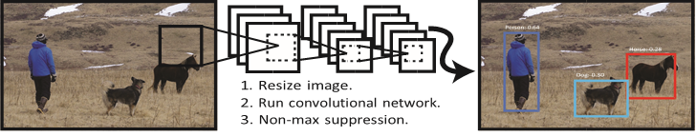 **Figure 1.11 (The YOLO Detection System. Processing images with YOLO is simple and straightforward)**

This unified model has several benefits over traditional methods of object detection.

First, YOLO is extremely fast. Since we frame detection as a regression problem, we don’t need a complex pipeline. We simply run our neural network on a new image at test time to predict detections. Our base network runs at 45 frames per second with no batch processing on a Titan X GPU and a fast version runs at more than 150 fps. This means we can process streaming video in real-time with less than 25 milliseconds of latency. Furthermore, YOLO achieves more than twice the mean average precision of other real-time systems.

Second, YOLO reasons globally about the image when making predictions. Unlike sliding window and region proposal-based techniques, YOLO sees the entire image during training and test time so it implicitly encodes contextual information about classes as well as their appearance. Fast R-CNN, a top detection method [4], mistakes background patches in an image for objects because it can’t see the larger context. YOLO makes less than half the number of background errors compared to Fast R-CNN.

Third, YOLO learns generalizable representations of objects. When trained on natural images and tested on artwork, YOLO outperforms top detection methods like DPM and R-CNN by a wide margin. Since YOLO is highly generalizable it is less likely to break down when applied to new domains or unexpected inputs.

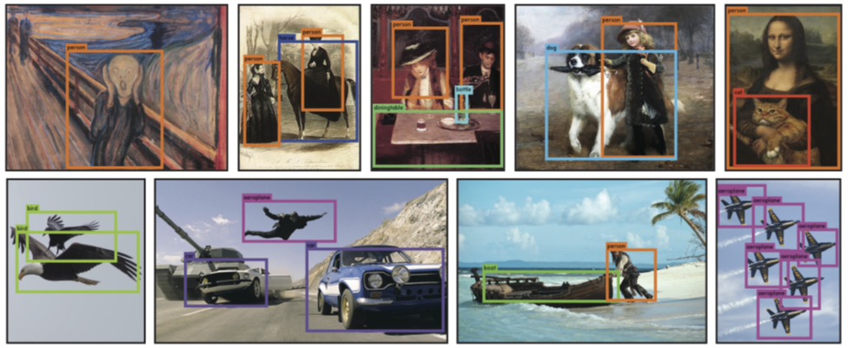**Figure 1.12 (Qualitative Results. YOLO running on sample artwork and natural images from the internet. It is mostly accurate although it does think one person is an airplane)**

YOLO still lags behind state-of-the-art detection systems in accuracy. While it can quickly identify objects in images it struggles to precisely localize some objects, especially small ones. We examine these tradeoffs further in our experiments.

* **How YOLO works?**

We unify the separate components of object detection into a single neural network. Our network uses features from the entire image to predict each bounding box. It also predicts all bounding boxes across all classes for an image simultaneously. This means our network reasons globally about the full image and all the objects in the image. The YOLO design enables end-to-end training and real-time speeds while maintaining high average precision.

Our system divides the input image into an S × S grid. If the center of an object falls into a grid cell, that grid cell is responsible for detecting that object.

Each grid cell predicts B bounding boxes and confidence scores for those boxes. These confidence scores reflect how confident the model is that the box contains an object and also how accurate it thinks the box is that it predicts. Formally we define confidence as Pr(Object) ∗ IOUtruthpred . If no object exists in that cell, the confidence scores should be zero. Otherwise, we want the confidence score to equal the intersection over union (IOU) between the predicted box and the ground truth.

Each bounding box consists of 5 predictions: x, y, w, h, and confidence. The (x,y) coordinates represent the centre of the box relative to the bounds of the grid cell. The width and height are predicted relative to the whole image. Finally, the confidence prediction represents the IOU between the predicted box and any ground truth box.

Each grid cell also predicts C conditional class probabilities, Pr(Classi|Object). These probabilities are conditioned on the grid cell containing an object. We only predict one set of class probabilities per grid cell, regardless of the number of boxes *B*.

At test time we multiply the conditional class probabilities and the individual box confidence predictions,

Pr(Class*i*|Object) ∗ Pr(Object) ∗ IOUpredTruth  = Pr(Class*i*) ∗ IOUpredTruth (1) which gives us class-specific confidence scores for each box. These scores encode both the probability of that class appearing in the box and how well the predicted box fits the object. These predictions are encoded as an S×S×(B∗5+C) tensor.

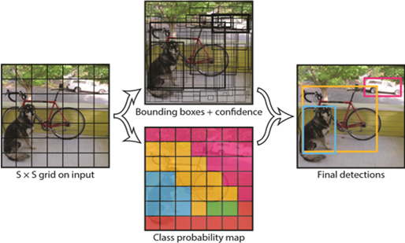**Figure 1.13 (The Model. Our system models detection as a regression problem. It divides the image into an S×S grid and for each grid cell predicts B bounding boxes, confidence for those boxes, and C class probabilities)**

* **Network design of YOLO**

We implement this model as a convolutional neural network and evaluate it on the PASCAL VOC detection dataset [1]. The initial convolutional layers of the network extract feature from the image while the fully connected layers predict the output probabilities and coordinates.

Our network architecture is inspired by the GoogLeNet model for image classification [10]. Our network has 24 convolutional layers followed by 2 fully connected layers. Instead of the inception modules used by GoogLeNet, we simply use 1×1 reduction layers followed by 3×3 convolutional layers, similar to Lin et al [5]. The full network is shown in Figure 3.

We also train a fast version of YOLO designed to push the boundaries of fast object detection. Fast YOLO uses a neural network with fewer convolutional layers (9 instead of 24) and fewer filters in those layers. Other than the size of the network, all training and testing parameters are the same between YOLO and Fast YOLO.

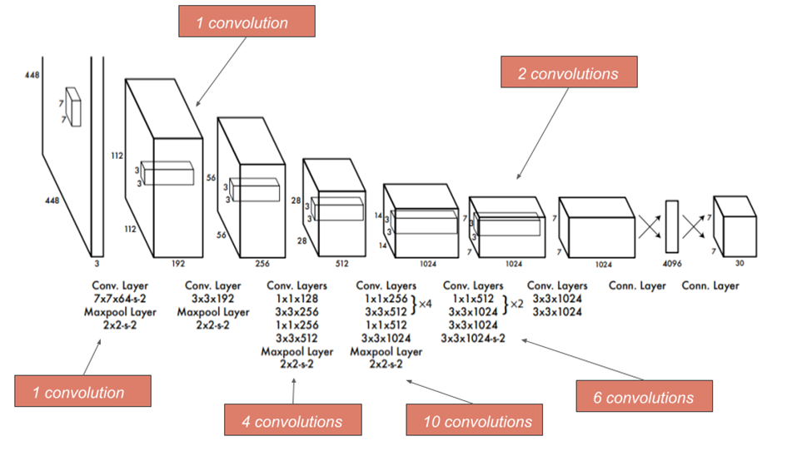**Figure 1.14 (The Architecture. Our detection network has 24 convolutional layers followed by 2 fully connected layers. Alternating 1×1 convolutional layers reduce the features space from preceding layers)**

* **Training of YOLO**

We pretrain our convolutional layers on the ImageNet 1000-class competition dataset [9]. For pretraining we use the first 20 convolutional layers from Figure 3 followed by a

average-pooling layer and a fully connected layer. We train this network for approximately a week and achieve a single crop top-5 accuracy of 88% on the ImageNet 2012 validation set, comparable to the GoogLeNet models in Caffe’s Model Zoo [6]. We use the Darknet framework for all training and inference [7].

We then convert the model to perform detection. Ren et al. show that adding both convolutional and connected layers to pretrained networks can improve performance [8]. Following their example, we add four convolutional layers and two fully connected layers with randomly initialized weights. Detection often requires fine-grained visual information so we increase the input resolution of the network from 224 × 224 to 448 × 448.

Our final layer predicts both class probabilities and bounding box coordinates. We normalize the bounding box width and height by the image width and height so that they fall between 0 and 1. We parametrize the bounding box x and y coordinates to be offsets of a particular grid cell location so they are also bounded between 0 and 1.

We use a linear activation function for the final layer and all other layers use the following leaky rectified linear activation:

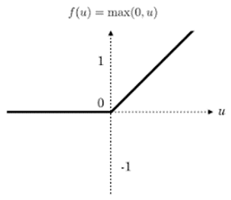

**Figure 1.15 (Rectified linear unit activation)**

We optimize for sum-squared error in the output of our model. We use sum-squared error because it is easy to optimize, however it does not perfectly align with our goal of maximizing average precision. It weights localization error equally with classification error which may not be ideal. Also, in every image many grid cells do not contain any object. This pushes the “confidence” scores of those cells towards zero, often overpowering the gradient from cells that do contain objects. This can lead to model instability, causing training to diverge early on.

To remedy this, we increase the loss from bounding box coordinate predictions and decrease the loss from confidence predictions for boxes that don’t contain objects. We use two parameters, λcoord and λnoobj to accomplish this. We set λcoord = 5 and λnoobj = .5.

Sum-squared error also equally weights errors in large boxes and small boxes. Our error metric should reflect those small deviations in large boxes matter less than in small boxes. To partially address this, we predict the square root of the bounding box width and height instead of the width and height directly.

YOLO predicts multiple bounding boxes per grid cell. At training time, we only want one bounding box predictor to be responsible for each object. We assign one predictor to be “responsible” for predicting an object based on which prediction has the highest current IOU with the ground truth. This leads to specialization between the bounding box predictors. Each predictor gets better at predicting certain sizes, aspect ratios, or classes of object, improving overall recall. To avoid overfitting, we use dropout and extensive data augmentation. A dropout layer with rate = .5 after the first connected layer prevents co-adaptation between layers [11].

* **How YOLO detect after training?**

Just like in training, predicting detections for a test image only requires one network evaluation. On PASCAL VOC the network predicts 98 bounding boxes per image and class probabilities for each box. YOLO is extremely fast at test time since it only requires a single network evaluation, unlike classifier-based methods.

The grid design enforces spatial diversity in the bounding box predictions. Often it is clear which grid cell an object falls in to and the network only predicts one box for each object. However, some large objects or objects near the border of multiple cells can be well localized by multiple cells. Non-maximal suppression can be used to fix these multiple detections. While not critical to performance as it is for R-CNN or DPM, non-maximal suppression adds 23% in mAP (Mean Average Precision).

* **Limitations of YOLO**

YOLO imposes strong spatial constraints on bounding box predictions since each grid cell only predicts two boxes and can only have one class. This spatial constraint limits the number of nearby objects that our model can predict. Our model struggles with small objects that appear in groups, such as flocks of birds.

Since our model learns to predict bounding boxes from data, it struggles to generalize to objects in new or unusual aspect ratios or configurations. Our model also uses relatively coarse features for predicting bounding boxes since our architecture has multiple down sampling layers from the input image.

Finally, while we train on a loss function that approximates detection performance, our loss function treats errors the same in small bounding boxes versus large bounding boxes. A small error in a large box is generally benign but a small error in a small box has a much greater effect on IOU. Our main source of error is incorrect localizations.

### R-CNN

R-CNNs (Region-based Convolutional Neural Networks) a family of machine learning models Specially designed for object detection; the original goal of any R-CNN is to detect objects in any input image.

An input image given to the R-CNN model goes through a mechanism called selective search to extract information about the region of interest. Region of interest can be represented by the rectangle boundaries. Depending on the scenario there can be over 2000 regions of interest. This region of interest goes through CNN to produce output features. These output features then go through the SVM (support vector machine) classifier to classify the objects presented under a region of interest.

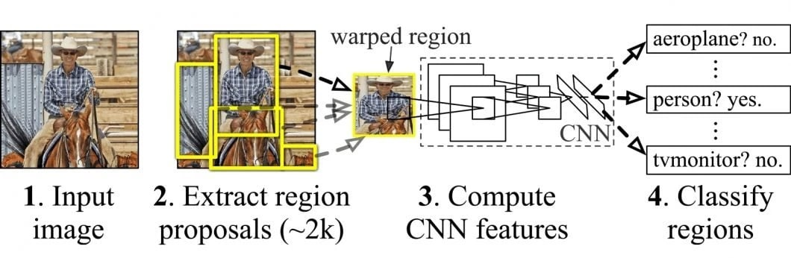 **Figure 1.16 (How R-CNN works)**

* **Stages of R-CNN**
* **Bounding box regression**

In order to improve localization performance, the authors include a bounding-box regression step to learn corrections in the predicted bounding box location and size.

* **SVM for object classification**

This stage consists of learning an individual linear SVM (Support Vector Machine) classifier for each class, that detects the presence or absence of an object belonging to a particular class.

* **Feature extraction from Region Proposals**

At the end of this stage in the pipeline, the authors generate a 4096-dimensional feature vector from each of the 2000 region proposals for every image using a Convolutional Neural Network (CNN).

* **Tasks performed by R-CNN?**
* **Selective Search**:

There can be various approaches to perform object localization in any object detection procedure. Using sliding filters of different sizes on the image to extract the object from the image can be one approach that we call an exhaustive search approach. As the number of filters or windows will increase, the computation effort will increase in an exhaustive search approach.

The selective search algorithm uses exhaustive search but instead of using it alone it also works with the segmentation of the colours presented in the image. More formally we can say selective search is a method that separates objects from an image by providing different colours to the object.

* **Warping**:

After selection of the region, the image with regions goes through a CNN where the CNN model extracts the objects from the region. Since the size of the image should be fixed according to the capacity of CNN, we require some time or most of the time to reshape the image. In basic R-CNN we wrap the region into 227 x 227 x 3 size images.

* **Extract objects with a CNN**:

A wrapped input for CNN will be processed to extract the object of size 4096 dimensions.

* **Classification**:

The basic R-CNN consists of an SVM classifier to segregate different objects into their class.

* **Comparing R-CNN, Fast R-CNN and Faster R-CNN**

Now, let us compare the important features of all these models that we have gone through.

**Table ‎1.1(Comparing R-CNN, Fast R-CNN and Faster R-CNN)**

|  |  |  |
| --- | --- | --- |
| **R-CNN** | **Fast R-CNN** | **Faster R-CNN** |
| Region proposals method | Selective search | Selective search | Region proposal network |
| Prediction timing | 40-50 sec | 2 seconds | 0.2 seconds |
| computation | High computation time | High computation time | Low computation time |
| The map on Pascal VOC 2007 test dataset (%) | 58.5 | 66.9 (when trained with VOC 2007 only) 70.0 (when trained with VOC 2007 and 2012 both) | 69.9(when trained with VOC 2007 only) |
| The map on Pascal VOC 2012 test dataset (%) | 53.3 | 65.7 (when trained with VOC 2012 only) 68.4 (when trained with VOC 2007 and 2012 both) | 67.0(when trained with VOC 2012 only) 70.4 (when trained with VOC 2007 and 2012 both) 75.9(when trained with VOC 2007 and 2012 and COCO) |

### SSD

* **Introduction to Single Shot Detector (SSD)**

SSD is an object detection model, but what exactly does object detection mean? A lot of people confuse object detection with image classification. In simple words, image classification says what the picture or image is, while object detection finds out the different things in the image and tells where they are in the image with the help of bounding boxes. With that cleared let's jump into SSD.

The famous single shot detectors are YOLO (you look only once) and Single Shot detector. [12]

* **What makes SSD special?**

As said above the SSD model detects objects in a single pass, which means it saves a lot of time. But at the same time, the SSD model also seems to have amazing accuracy in its detection.

In order to achieve high detection accuracy, the SSD model produces predictions at different scales from the feature maps of different scales and explicitly separates predictions by aspect ratio. [12]

* **Structure / Architecture of SSD model** (The SSD model is made up of 2 parts namely)
* **The backbone model**

The Backbone model is a typical pre-trained image classification network that works as the feature map extractor. Here, the image final image classification layers of the model are removed to give us only the extracted feature maps. [13]

* **The SSD head**

SSD head is made up of a couple of convolutional layers stacked together and it is added to the top of the backbone model. This gives us the output as the bounding boxes over the objects. These convolutional layers detect the various objects in the image. [13]

* **How does SSD work?**

The SSD is based on the use of convolutional networks that produce multiple bounding boxes of various fixed sizes and scores the presence of the object class instance in those boxes, followed by a non-maximum suppression step to produce the final detections

Note: In this model, we will be discussing the SSD built on the VGG-16 network as its backbone model. But the SSD can also be implemented using various other backbone models.

The SSD model works as follows, each input image is divided into grids of various sizes and at each grid, the detection is performed for different classes and different aspect ratios. And a score is assigned to each of these grids that says how well an object matches in that particular grid. And non-maximum suppression is applied to get the final detection from the set of overlapping detections. This is the basic idea behind the SSD model.

Here we use different grid sizes to detect objects of different sizes, for example, look at the image given below when we want to detect the cat smaller grids are used but when we want to detect a dog the grid size is increased which makes the SSD more efficient. [12]

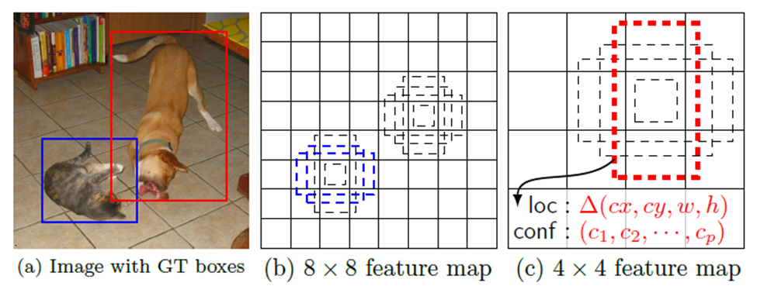 **Figure 1.17 (Efficient of SSD)**

* **Detections using multi-scale feature maps**

The multi-scale feature maps are added to the end of the truncated backbone model. These multi-scale feature maps reduce in size progressively, which allows the detections at various scales of the image. The convolutional layers used here vary for each feature layer. [14]

* **Detection using the convolutional predictors**

The addition of each extra layer produces a fixed number of predictions using the convolutional filters in them. These additional layers are shown at the top of the model in the given diagram below. For example, a feature layer of size m x n with p channels, the minimal prediction parameter that gives a decent detection is a 3 x 3 x p small kernel. Such kernel gives us the score for a category or a shape offset relative to the default box coordinates. [14]

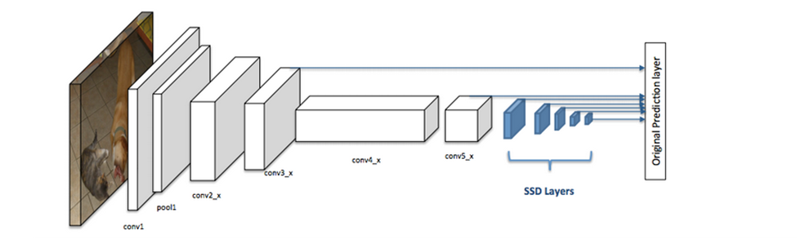

**Figure 1.18 (Layers of SSD)**

* **Usage of Default Boxes and aspect ratios**

The default bounding boxes are associated with every feature map cell at the top of the network. These default boxes tile the feature map in a convolutional manner such that the position of each box relative to its corresponding cell is fixed.

For each box out of k at a given location, c class scores are computed and 4 offset relatives to the original default box shape. This results in the total of (c+4) k filters that are applied around each location in the feature map, yielding (c+4) kmn outputs for a feature map of size m x n.

This allows the usage of different default box shapes in several feature maps and makes the model efficiently discretize the space of possible output box shapes. [14]

**Table ‎1‑2(The table given below gives the details about all the operations in the SSD head)**

| **TYPE / NAME** | **GRID SIZE** | **KERNEL SIZE** |
| --- | --- | --- |
| Conv 6 | 19×19 | 3x3x1024 |
| Conv 7 | 19×19 | 1x1x1024 |
| Conv 8_2 | 10×10 | 1x1x256 3x3x512-s2 |
| Conv 9_2 | 5×5 | 1x1x128 3x3x256-s2 |
| Conv 10_2 | 3×3 | 1x1x128 3x3x256-s1 |
| Conv 11_2 | 1×1 | 1x1x128 3x3x256-s1 |

* **YOLO vs SSD**

The You look only once (YOLO) model is a predecessor to the SSD model, it also detects images in a single pass, but it uses two fully connected layers while the SSD uses multiple convolutional layers. The SSD model adds several feature layers to the end of a base network, which predicts the offsets to default boxes of different scales and aspect ratios and their associated scores.

The SSD produces an average of 8732 detections per class while the YOLO produces only 98 predictions per class.

An SSD with a 300 x 300 inputs size significantly outperforms a 448 x 448 YOLO counterpart in accuracy as well as speed in the VOC2007 test. [15]

* **Performance of SSD**

The SSD model is proven to show better results than the previous state-of-the-art detection algorithms like YOLO and Faster R-CNN. The multi-output layers at different resolutions have impacted the performance hugely, in fact, even removal of few layers resulted in a decrease in the accuracy by 12%. [15]

**Table ‎1‑3(Performance comparison with other models)**

| **SYSTEM** | **VOC2007 TEST MAP** | **FPS (TITAN X)** | **NUMBER OF BOXES** | **INPUT RESOLUTION** |
| --- | --- | --- | --- | --- |
| Faster R-CNN (VGG16) | 73.2 | 7 | ~6000 | ~1000 X 600 |
| YOLO (customized) | 63.4 | 45 | 98 | 448 X 448 |
| SSD300* (VGG16) | 77.2 | 46 | 8732 | 300 X 300 |
| SSD512* (VGG16) | 79.8 | 19 | 24564 | 512 X 512 |

The SSD model is one of the fastest and efficient object detection models for multiple categories. And it has also opened new doors in the domain of object detection.

## motivation

In 2020 the world got a disaster called Covid-19 (Corona virus) that came on the whole world and continued in spreading till now, so that many several countries changed the educational system to the online learning to Applying precautionary measures. But many faculties got affected in their educational level because it is a surprising disaster. This motivated us to create an application that contributes and helps in applying precautionary measures and curbing that virus by following up and alerting people to take the necessary measures and wear a mask.

## PROBLEM DEFINITION

Because of the precautionary measures and the changes inthe education system in Egypt, students of the faculties from departments cannot get the lectures in the faculty because of applying the precautionary measures so that they have to study from the books with the photos in it without seeing the code, also after the quarantine students cannot get closer to each other to see what the lecturer say to not help in the spreading of Covid-19 (Corona Virus). Also, if the students enter in separated groups this will take a lot of time and efforts from the lecturers to finish the lectures. So, we decided to make detecting the people without mask easier and provide this project to can help in it.

## Project Objectives

* Detect students without mask and with mask and the students who wear mask in wrong way.
* Make teaching easier for the lecturers who can make sure that almost all students wear mask.
* And it can also help in companies that can make sure that staff wear the mask
* Help for preventing the spread of COVID-19.
* Good for any crowded place help in detecting the people without mask and who wear the mask in wrong way.

## Business Value (Benefits)

* Detecting whether a person is wearing a mask or not.
* Protect against COVID-19 virus and other viruses.

Chapter Four

# Implementation

## Introduction

Discuss the dataset, used tools source code and show the output of the application.

## Dataset

This part talks about dataset in terms of its meaning, types, properties, and use in machine learning and preparing in terms of compiling, processing, splitting, and defining its extension to do training by model.

### Dataset Meaning

A data set is an ordered collection of data. As we know, a collection of information obtained through observations, measurements, study, or analysis is referred to as data. It could include information such as facts, numbers, figures, names, or even basic descriptions of objects. For our study, data can be organized in the form of graphs, charts, or tables. Through data mining, data scientists assist in the analysis of gathered data. [3.1]

A dataset is a set of numbers or values that pertain to a specific topic. A dataset is, for example, each student’s test scores in a certain class. Datasets can be written as a list of integers in a random order, a table, or with curly brackets around them. The data sets are normally labelled so you understand what the data represents, however, while dealing with data sets, you don’t always know what the data stands for, and you don’t necessarily need to realize what the data represents to accomplish the problem. [3.1]

### Types of Datasets

In Statistics, we have different types of data sets available for different types of information. They are [3.1]:

* Types of Datasets
* Numerical data sets
* Bivariate data sets
* Multivariate data sets
* Categorical data sets
* Correlation data sets

### Properties of Dataset

Before performing any statistical analysis, it is essential to understand the nature of the data. We can use different Exploratory Data Analysis (EDA techniques), which helps to identify the properties of data, so that the appropriate statistical methods can be applied on the data. With the help of EDA techniques, we can check the following properties of the dataset. [16]

* Centre of data
* Skewness of data
* Spread among the data members
* Presence of outliers
* Correlation among the data
* Type of probability distribution that the data follows

### What Is a Dataset in Machine Learning and Why Is It Essential for Your AI Model?

* Oxford Dictionary defines the dataset as (a collection of data that is treated as a single unit by a computer). This means that a dataset contains a lot of separate pieces of data but can be used to train an algorithm with the goal of finding predictable patterns inside the whole dataset.
* Dataset contains a lot of separate pieces of data but can be used to train an algorithm with the goal of finding predictable patterns inside the whole dataset. Data is very important component of any AI model and, basically, the sole reason for the spike in popularity of machine learning that we witness today. Due to the availability of data, scalable ML algorithms became viable as actual products that can bring value to a business, rather than being a by-product of its main processes.
* Your business has always been based on data. Factors such as what the customer bought, the popularity of the products, seasonality of the customer flow have always been important in business making. However, with the advent of machine learning, now it's important to collect this data into datasets. Sufficient volumes of data allow you to analyze the trends and hidden patterns and make decisions based on the dataset you've built. However, while it may look rather simply, working with data is more complicated since it requires, first of all, proper treatment of the data you have, from the purposes of using a dataset to the preparation of the raw data for it to be actually usable. [17]

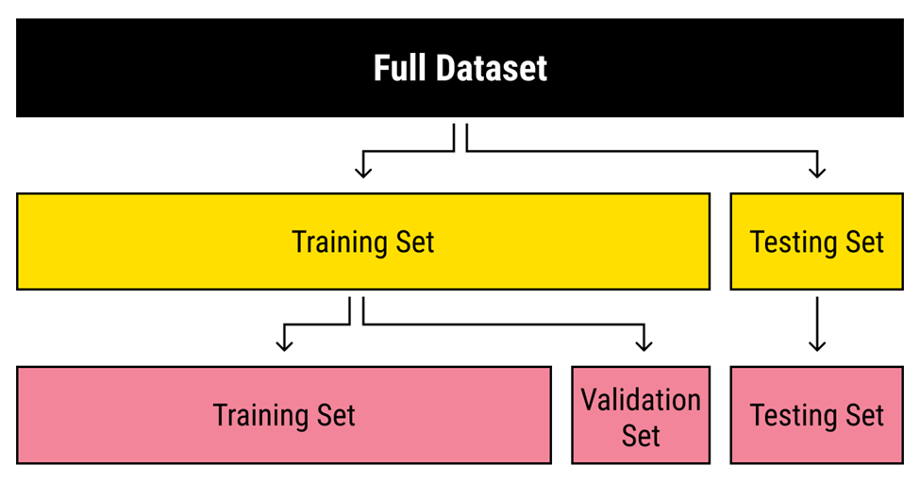

**Figure 1.19 (Divide the dataset)**

* In machine learning, a common task is the study and construction of algorithms that can learn from and make predictions on data. [18] Such algorithms function by making data-driven predictions or decisions, [19] through building a mathematical model from input data. These input data used to build the model are usually divided in multiple data sets. In particular, three data sets are commonly used in different stages of the creation of the model: training, validation and test sets.
* The model is initially fit on a training data set, [20] which is a set of examples used to fit the parameters (e.g., weights of connections between neurons in artificial neural networks) of the model. [21] The model (e.g., a naive Bayes classifier) is trained on the training data set using a supervised learning method, for example using optimization methods such as gradient descent or stochastic gradient descent. In practice, the training data set often consists of pairs of an input vector (or scalar) and the corresponding output vector (or scalar), where the answer key is commonly denoted as the target (or label). The current model is run with the training data set and produces a result, which is then compared with the target, for each input vector in the training data set. Based on the result of the comparison and the specific learning algorithm being used, the parameters of the model are adjusted. The model fitting can include both variable selection and parameter estimation.
* Successively, the fitted model is used to predict the responses for the observations in a second data set called the validation data set. [20] The validation data set provides an unbiased evaluation of a model fit on the training data set while tuning the model's hyperparameters [22] (e.g., the number of hidden units—layers and layer widths—in a neural network [21]). Validation datasets can be used for regularization by early stopping (stopping training when the error on the validation data set increases, as this is a sign of over-fitting to the training data set). [23] This simple procedure is complicated in practice by the fact that the validation dataset's error may fluctuate during training, producing multiple local minima. This complication has led to the creation of many ad-hoc rules for deciding when over-fitting has truly begun. [23]
* Finally, the test data set is a data set used to provide an unbiased evaluation of a final model fit on the training data set. [22] If the data in the test data set has never been used in training (for example in cross-validation), the test data set is also called a holdout data set. The term "validation set" is sometimes used instead of "test set" in some literature (e.g., if the original data set was partitioned into only two subsets, the test set might be referred to as the validation set). [22]
* Deciding the sizes and strategies for data set division in training, test and validation sets is very dependent on the problem and data available. [24]

### What You Need to Know About Datasets in Machine Learning?

* Collecting a dataset for your AI project might seem like an easy task that can be done in the background while you pour most of your time and resources into building the machine learning model. However, as practice shows, time and time again, dealing with data might take most of your time due to the sheer scale that this task might grow to. For this reason, it's important to understand what a dataset in machine learning is, how to collect the data, and what features a proper dataset has.
* A dataset in machine learning is, quite simply, a collection of data pieces that can be treated by a computer as a single unit for analytic and prediction purposes. This means that the data collected should be made uniform and understandable for a machine that doesn't see data the same way as humans do. For this, after collecting the data, it's important to preprocess it by cleaning and completing it, as well as annotate the data by adding meaningful tags readable by a computer.
* Moreover, a good dataset should correspond to certain quality and quantity standards. For smooth and fast training, you should make sure your dataset is relevant and well-balanced. Try to use live data whenever possible and consult with experienced professionals about the volume of the data and the source to collect it from.
* Following these tips won't guarantee you collect a perfect dataset for your machine learning project. However, it will help you avoid some major pitfalls on your way to success.

### Dataset that has been prepared for our project

The dataset was prepared to work with algorithms to solve the problem of Face Mask Detection (FMD), and these algorithms were mentioned in the chapter (One) in part Detection Algorithms [YOLO, R-CNN, SSD].

It is clear that the types of data used are images, and those images are divided as follows, divided into three class [With Mask, Without Mask, Incorrect Mask].

### When do we use the dataset in the model to do training?

In order to use the dataset in the model for training, we must go through several stages: First: we collect the data, second: we prepare the data, thirdly: we divide the data, and the last stage: is to determine the extension to labels of the dataset.

### Dataset collection

We can collect the dataset by several ways, such as (taking pictures from the surrounding reality, or ready-made from sites such as (Kaggle, Roboflow, and others). [25]

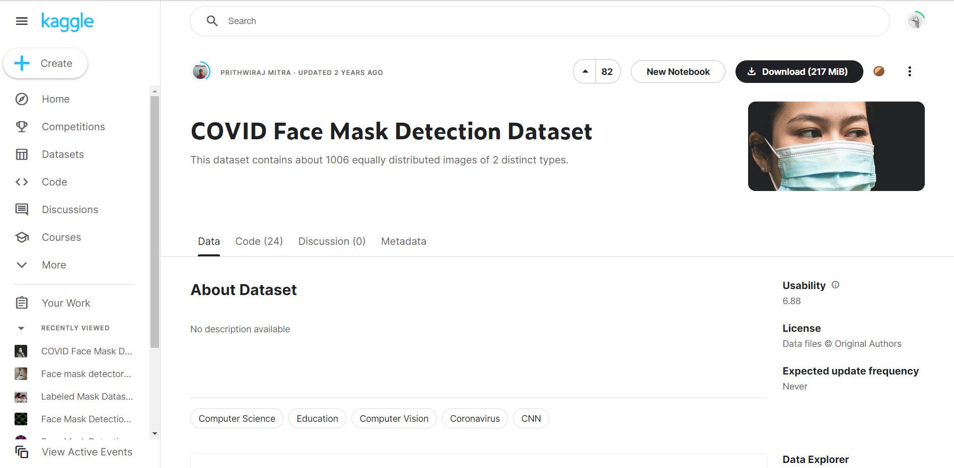

**Figure 1.20 (Dataset from Kaggle)**

### 4.1.6.1.2 Dataset processing

In order to process the dataset, we must know the type of problem that we will face in the dataset (images), for example, if there is (noise, distortion, and other such types of problems) in that case we use image processing.

But in our dataset type, the problem that must be solved is that there must be a bounding box labelled by three classes [Incorrect Mask, With Mask, Without Mask] in order for the dataset to be ready for classification by the model to produce acceptable accuracy. [26]

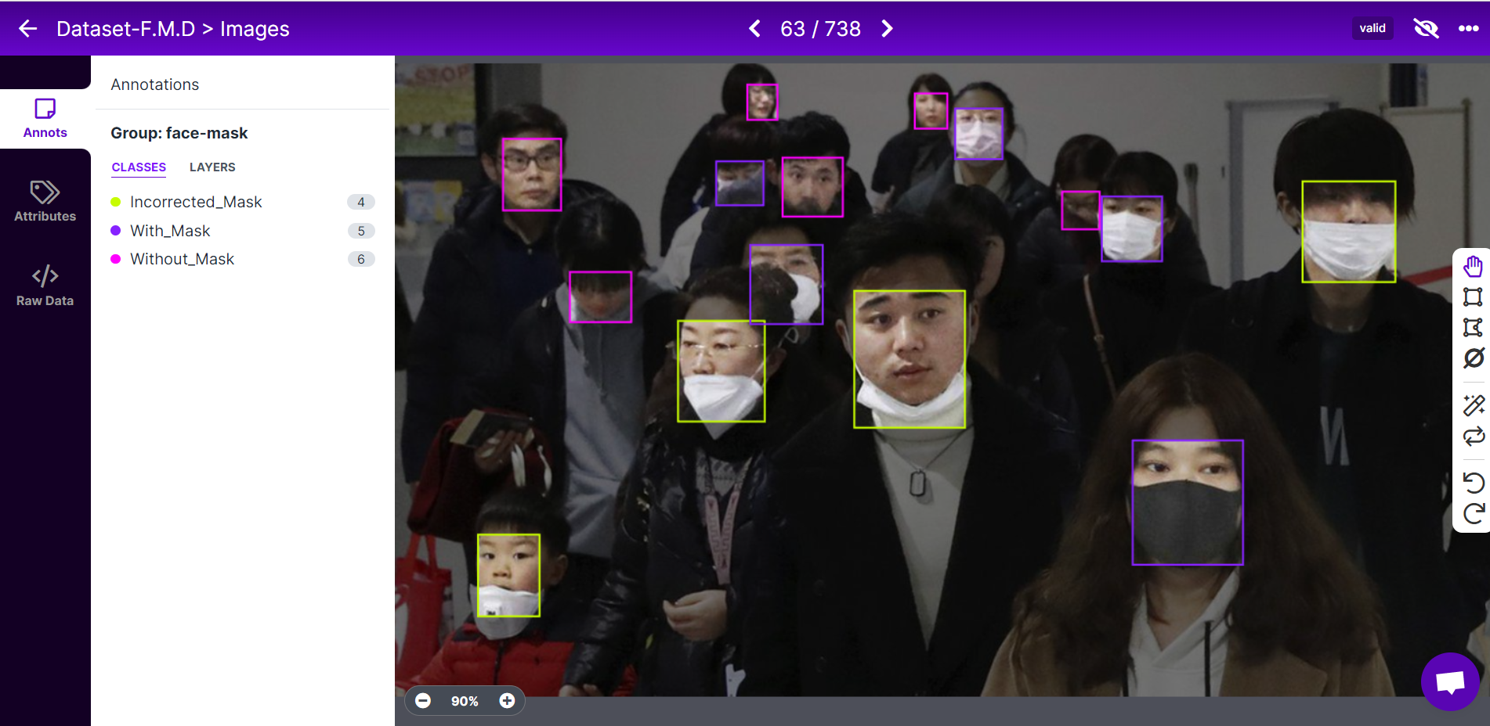 **Figure 1.21 (Bounding box by Roboflow)**

### Dataset splitting

As for splitting the dataset, it is uncomplicated and has different ways, either manually, which is not desirable, and the other is through programs, either by giving an order by code or by giving the ratios by which we want to divide the dataset, and for our data we have done the splitting process through the Roboflow website. [26]

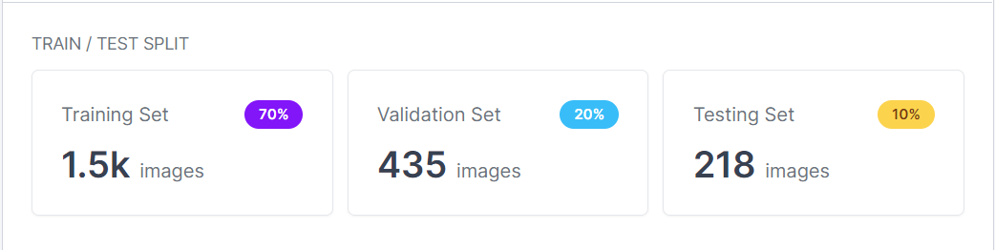 **Figure 1.22 (Splitting dataset by Roboflow)**

### Dataset labels extension type

The type of dataset extension is a matter that varies according to the type of model required to be filled with dataset; we used a Roboflow to choose the appropriate extension for each model. [26]

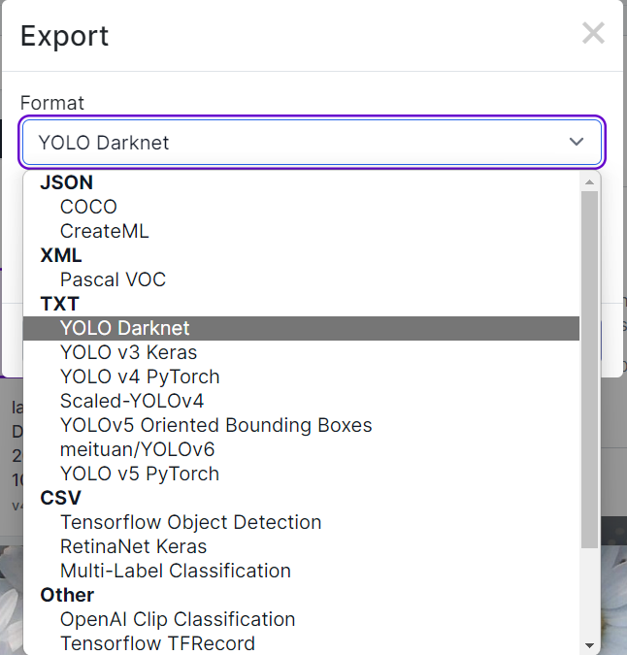

**Figure 1.23 (Extension selection to dataset by Roboflow)**

## Used Tools

We used several tools including [Open CV, PyCharm, TKINTER].

### Image Processing Library: Open CV (*Open-Source Computer Vision Library*)

Is a library of programming functions mainly aimed at real-time computer vision.[1] Originally developed by Intel, it was later supported by Willow Garage then It sees (which was later acquired by Intel [2])? The library is cross-platform and free for use under the open-source Apache 2 License. Starting with 2011, OpenCV features GPU acceleration for real-time operations.

### Editor: PyCharm

PyCharm (nowadays) is generally recommended to use for Image Processing, as it is the best and most proficient IDE for Python.

### Gul Library: TKINTER

The TKINTER package (“Tk interface”) is the standard Python interface to the TCI/Tk GUI toolkit. Both Tk and TKINTER are available on most Unix platforms, including macOS, as well as on Windows systems. TKINTER supports a range of TCI /Tk versions, built either with or without thread support. The official Python binary release bundles TCI /Tk 8.6 threaded. See the source code for the TKINTER module for more information about supported versions.TKINTER is not a thin wrapper but adds a fair amount of its own logic to make the experience more pythonic. This documentation will concentrate on these additions and changes and refer to the official TCI /Tk documentation for details that are unchanged.

## Imported Libraries

This script shows the libraries we imported to our project.

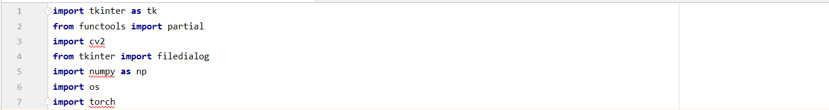 **Figure 1.24 (Imported Libraries)**

## GuI main window components

This script shows the components initialization of the main window.

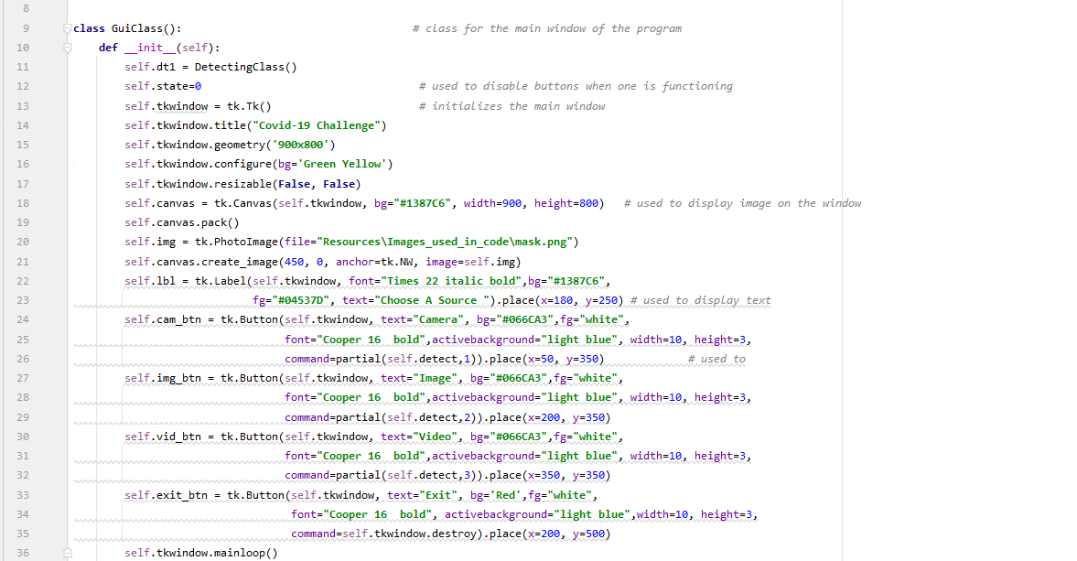 **Figure 1.25 (Main Form Class initialization)**

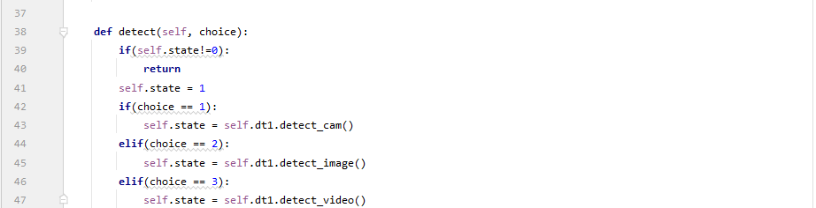**Figure 1.26 (Method from Main Form Class)**

## Detecting Class

In this class we import the model and start using it on real-time camera, video recording or image and save the results.

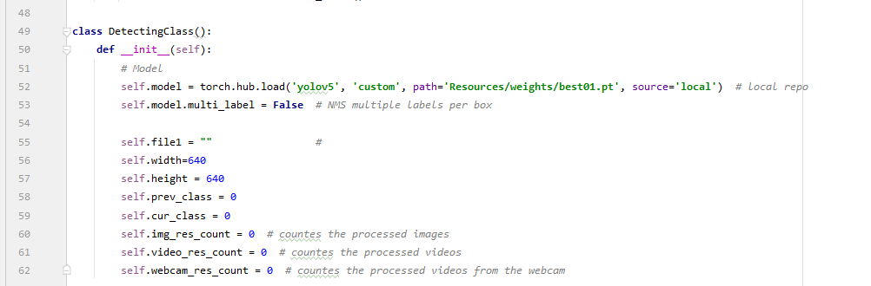**Figure 1.27 (Detecting Class Initialization)**

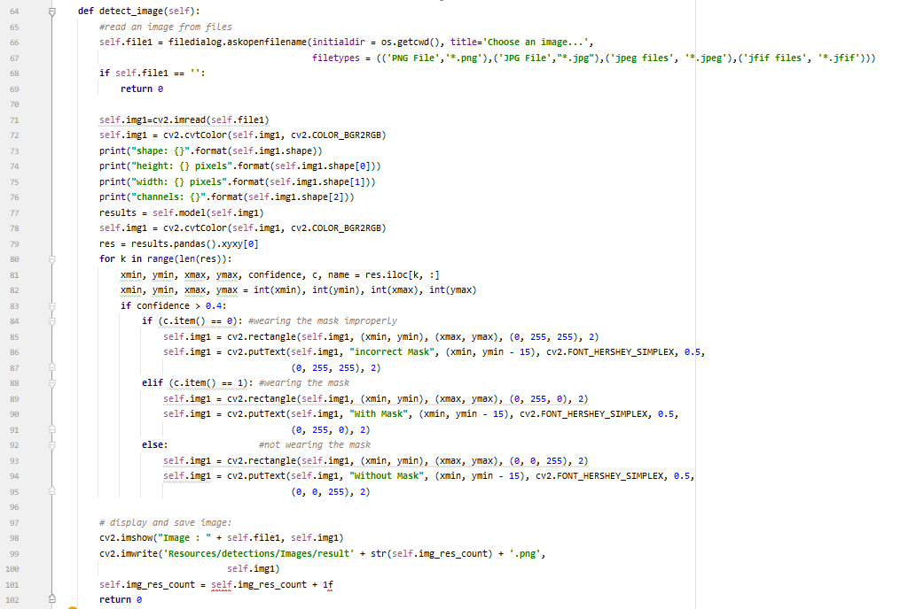 **Figure 1.28 (Image Method from Detecting Class)**

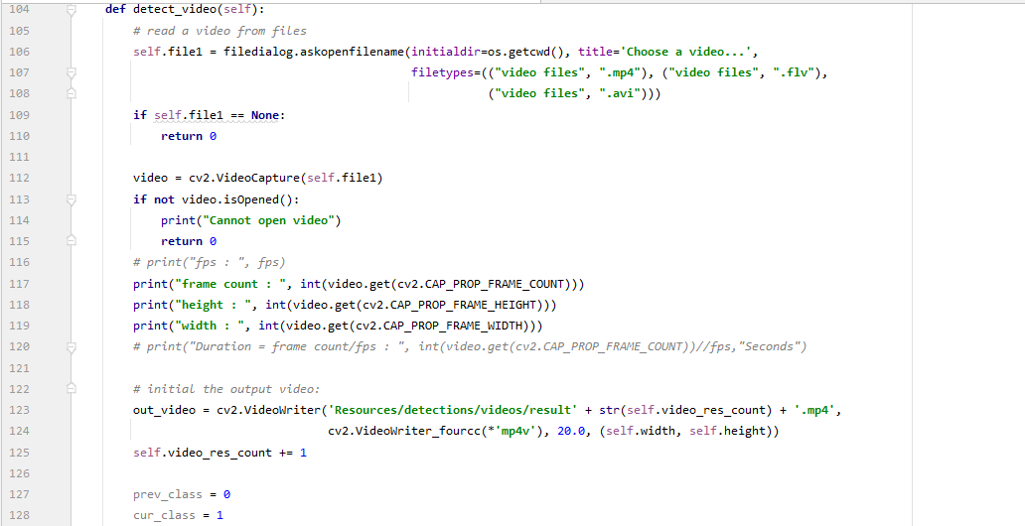

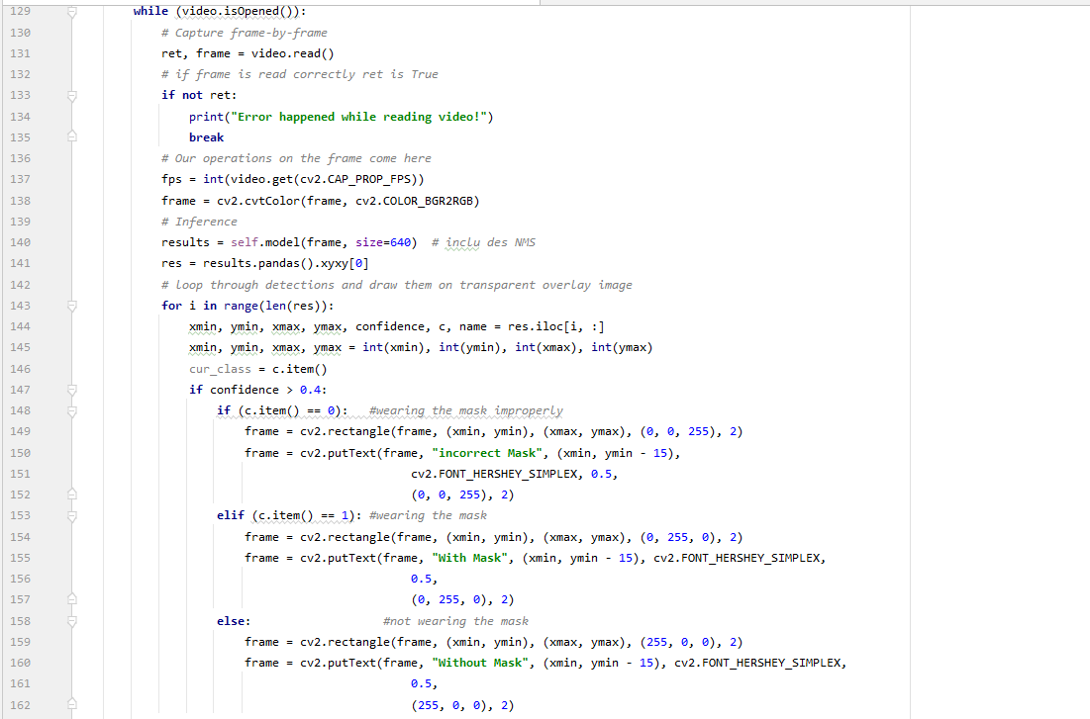

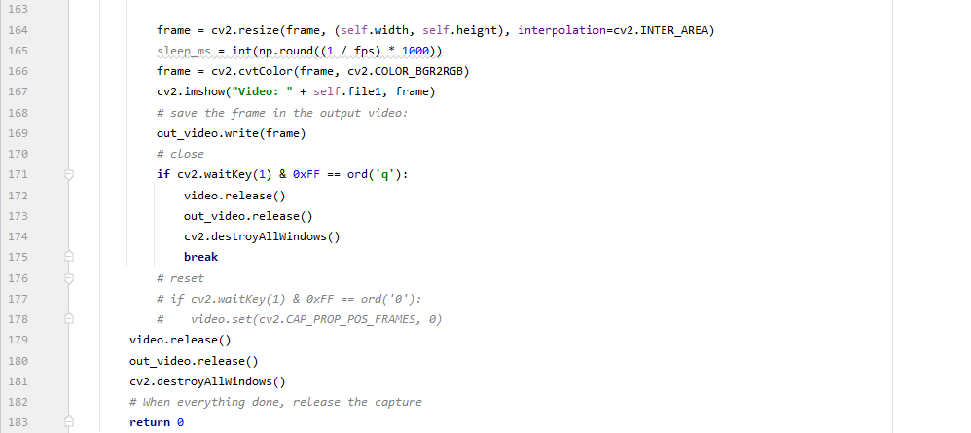

**Figure 1.29 (Video Method from Detecting Class)**

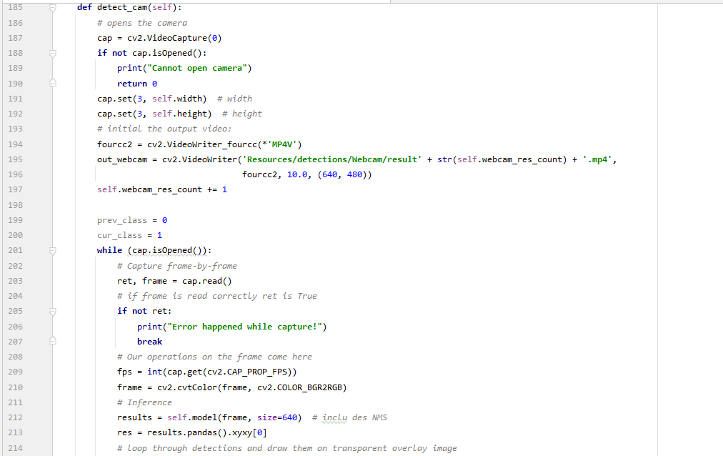

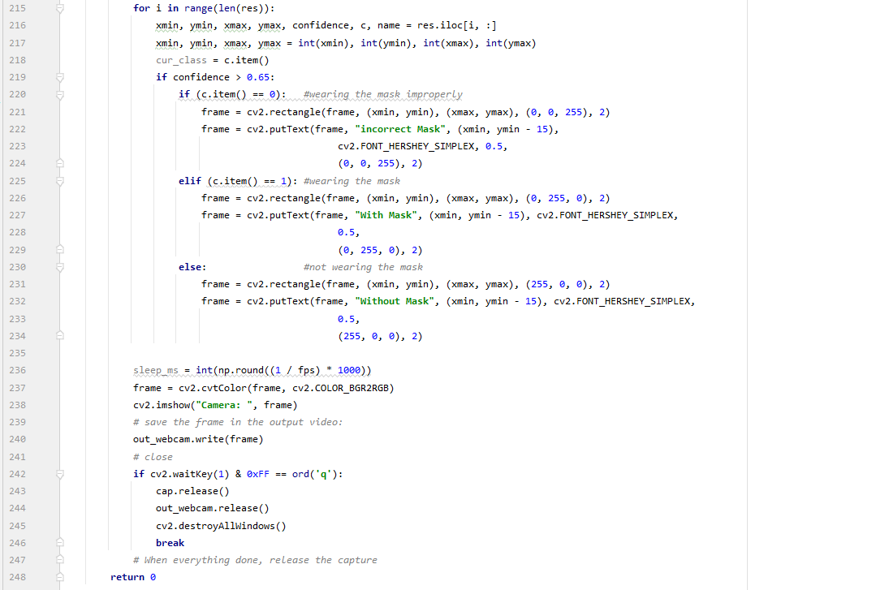

**Figure 1.30 (Real-Time Camera Method from Detecting Class)**



**Figure 1.31 (Start of the execution)**

Chapter Five

# The proposed of application

## Introduction

Discuss The user interface and show the testing of the application, The desktop application has three options, you can open the webcam to detect the face mask in a live way, or you can select a picture from your device and send it to the application, and the application detect the face mask, or you can select a video from your device and enter it into the application, and the application detect the face mask as well.

## User interface

This is the first scene that the user can see.

### First scene

The user can choose his option, there are three buttons as illustrated in figure 1.22

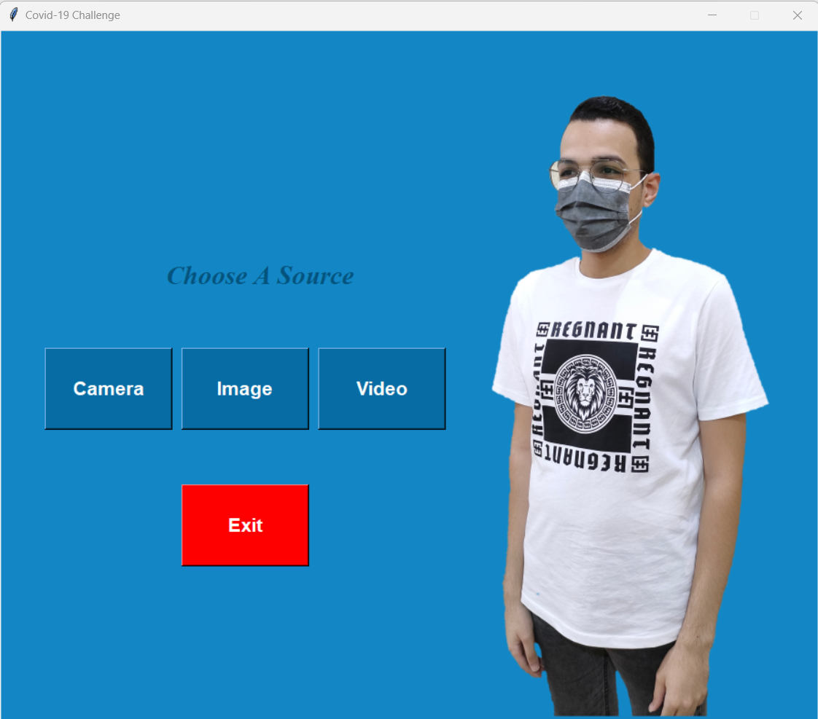  **Figure 1.32 (First scene of the app)**

### Open Web cam

Once the user press “camera” button as in figure 3.1 the web cam interface will be loaded and model will run.

### Open Image

Once the user press “image” button as in figure 3.1 the choose image interface will be loaded. Then select your image and click open. The model will run and detect face mask.

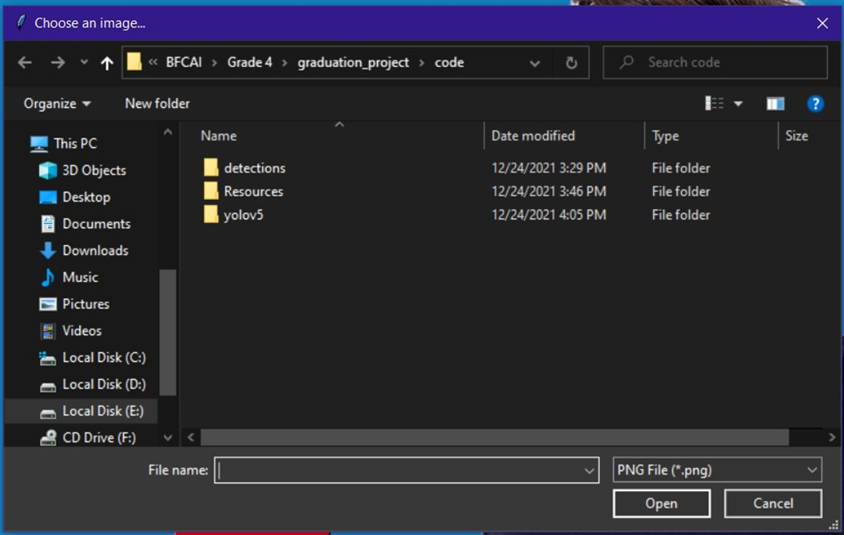 **Figure 1.33 (Choose an image)**

### Open Video

Once the user press “video” button as in figure 3.1 the choose video interface will be loaded. Then select your video and click open.

The model will run and detect face mask.

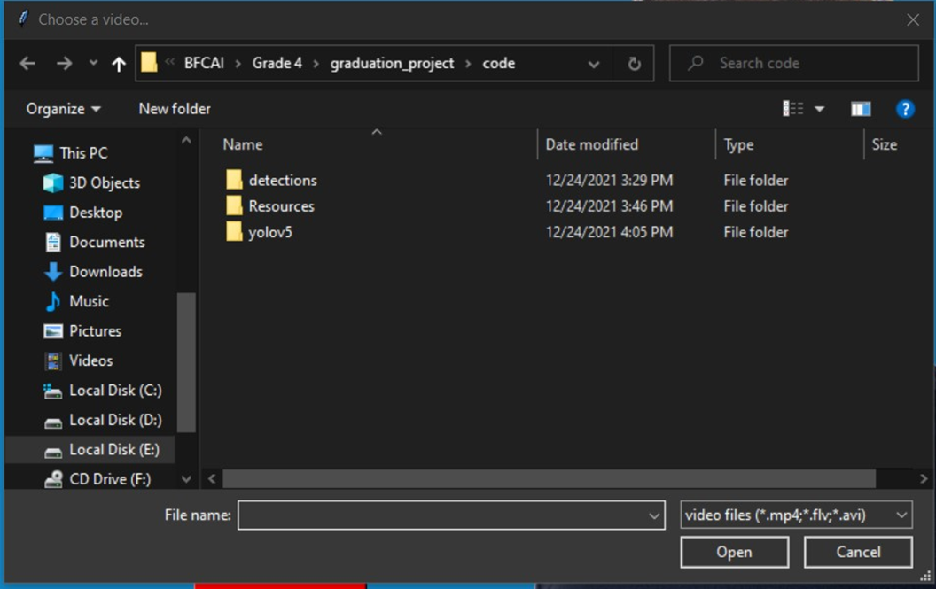**Figure 1.34 (Choose a video)**

## Testing of the application

The application has three options (Web Cam, Image, Video).

### First Testing: Select Web Cam

Open the webcam to detect the face mask in a live way, The model can detect the face mask to the people in front of the webcam, one person or several people, it can also detect the people who wear the mask incorrectly.

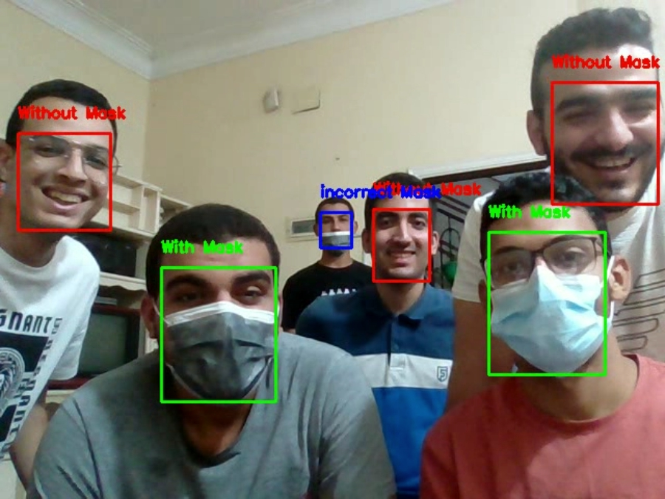  **Figure 1.35 (Webcam real-time)**

### Second Testing: Select Image

you can select a picture from your device and send it to the application, and the application detect the face mask. The model can detect the face mask, it can also detect the people who wear the mask incorrectly.

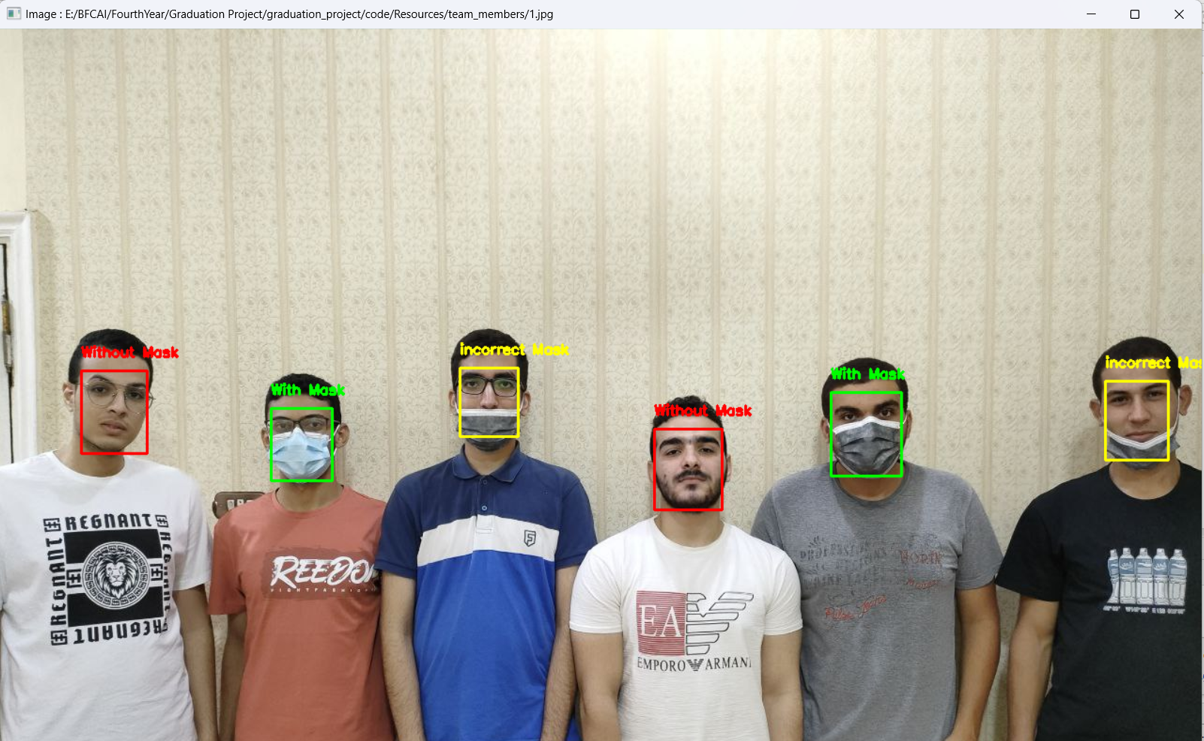

**Figure 1.36 (Image with-mask, without-mask, incorrect-mask)**

### Third Testing: Select Video

you can select a video from your device and enter it into the application, and the application detect the face mask as well. The model can detect the face mask, it can also detect the people who wear the mask incorrectly.

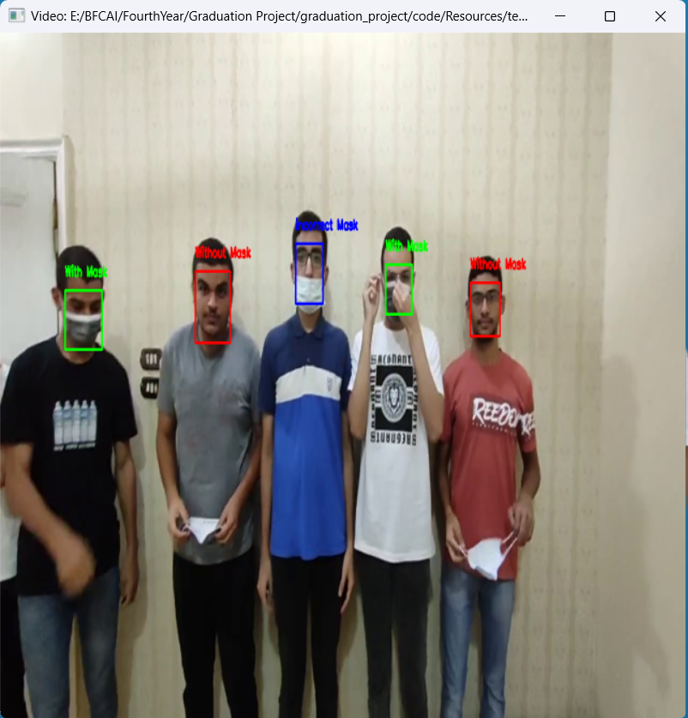

**Figure 1.37 (****Video with-mask, without-mask, incorrect-mask)**

Chapter Six

# Conclusion

## Introduction

Conclusions are presented to validate both the need for the study and explain how the present study solved the problem stated.

* Precautionary measures detection system to face the spread of infectious diseases is a detection application for the faculties of the departments which was developed to help in detecting the people who wear mask and don’t wear it and wear it in wrong way that help for preventing spread of COVID-19 virus and other viruses when applying the precautionary measures.
* It is also helpful application for crowded places that requires that all people wearing their own mask.

Chapter Seven

# future work

## Introduction

Improvements that can be added in the future to the system.

* Developing the application and make it better that can be used in wider places
* Increase the dataset to increase the performance of the application.
* Develop it on specialized hardware that make it useful on places that can’t provide software.
* Adding more advanced options in the application that make it easier to use and more efficient.
* Enable users to interact with the application without learning computer science and no need to learn how to deal with software.

Chapter Eight

# citaion and referencing

## Introduction

Show references that we use to do our application.

## REFERENCES TO ELECTRONIC SOURCES

[1] M. Everingham, S. M. A. Eslami, L. Van Gool, C. K. I. Williams, J. Winn, and A. Zisserman. The pascal visual object classes challenge: A retrospective. International Journal of Computer Vision, 111(1):98–136, Jan. 2015.

[2] P. F. Felzenszwalb, R. B. Girshick, D. McAllester, and D. Ramanan. Object detection with discriminatively trained part based models. IEEE Transactions on Pattern Analysis and Machine Intelligence, 32(9):1627–1645, 2010.

[3] R. Girshick, J. Donahue, T. Darrell, and J. Malik. Rich feature hierarchies for accurate object detection and semantic segmentation. In Computer Vision and Pattern Recognition (CVPR), 2014 IEEE Conference on, pages 580–587. IEEE, 2014.

[4] R. B. Girshick. Fast R-CNN. CoRR, abs/1504.08083, 2015.

[5] M. Lin, Q. Chen, and S. Yan. Network in network. CoRR, abs/1312.4400, 2013.

[6] D. Mishkin. Models accuracy on imagenet 2012 val. https://github.com/BVLC/caffe/wiki/ Models-accuracy-on-ImageNet-2012-val. Ac-

cessed: 2015-10-2.

[7] J. Redmon. Darknet: Open source neural networks in c. http://pjreddie.com/darknet/, 2013–2016.

[8] S. Ren, K. He, R. B. Girshick, X. Zhang, and J. Sun. Object detection networks on convolutional feature maps. CoRR, abs/1504.06066, 2015.

[9] O. Russakovsky, J. Deng, H. Su, J. Krause, S. Satheesh,

S. Ma, Z. Huang, A. Karpathy, A. Khosla, M. Bernstein, A. C. Berg, and L. Fei-Fei. ImageNet Large Scale Visual Recognition Challenge. International Journal of Computer Vision (IJCV), 2015.

[10] C. Szegedy, W. Liu, Y. Jia, P. Sermanet, S. Reed, D. Anguelov, D. Erhan, V. Vanhoucke, and A. Rabinovich. Going deeper with convolutions. CoRR, abs/1409.4842, 2014

[11] G. E. Hinton, N. Srivastava, A. Krizhevsky, I. Sutskever, and R. R. Salakhutdinov. Improving neural networks by preventing co-adaptation of feature detectors. arXiv preprint arXiv:1207.0580, 2012.

[12] <https://iq.opengenus.org/single-shot-detector/>

[13] <https://developers.arcgis.com/python/guide/how-ssd-works/>

[14] oseph Redmon, Santosh Divvala, Ross Girshick, Ali Farhadi: “You Only Look Once: Unified, Real-Time Object Detection”, 2015; [arXiv:1506.02640](https://arxiv.org/abs/1506.02640).

[15] Wei Liu, Dragomir Anguelov, Dumitru Erhan, Christian Szegedy, Scott Reed, Cheng-Yang Fu: “SSD: Single Shot MultiBox Detector”, 2016; [arXiv:1512.02325](http://arxiv.org/abs/1512.02325).

[16] [Datasets - Definition, Types, Properties and Examples (byjus.com)](https://byjus.com/maths/data-sets/)

[17] https://labelyourdata.com/articles/what-is-dataset-in-machine-learning#what_is_a_dataset_in_machine_learning_and_why_is_it_essential_for_your_ai_model

[18] Ron Kohavi; Foster Provost (1998). ["Glossary of terms"](https://ai.stanford.edu/~ronnyk/glossary.html). [Machine Learning](https://en.wikipedia.org/wiki/Machine_Learning_(journal)). **30**: 271–274. [doi](https://en.wikipedia.org/wiki/Doi_(identifier)):[10.1023/A:1007411609915](https://doi.org/10.1023%2FA%3A1007411609915)..

[19] Bishop, Christopher M. (2006). Pattern Recognition and Machine Learning. New York: Springer. p. vii. [ISBN](https://en.wikipedia.org/wiki/ISBN_(identifier)) [0-387-31073-8](https://en.wikipedia.org/wiki/Special:BookSources/0-387-31073-8). Pattern

[20] recognition has its origins in engineering, whereas machine learning grew out of computer science. However, these activities can be viewed as two facets of the same field, and together they have undergone substantial development over the past ten years.

[21] [Jump up to:**a**](https://en.wikipedia.org/wiki/Training,_validation,_and_test_data_sets#cite_ref-James_2013_176_3-0) [**b**](https://en.wikipedia.org/wiki/Training,_validation,_and_test_data_sets#cite_ref-James_2013_176_3-1) James, Gareth (2013). [An Introduction to Statistical Learning: with Applications in R](http://www-bcf.usc.edu/~gareth/ISL/). Springer. p. 176. [ISBN](https://en.wikipedia.org/wiki/ISBN_(identifier)) [978-1461471370](https://en.wikipedia.org/wiki/Special:BookSources/978-1461471370).

[22] [Jump up to:**a**](https://en.wikipedia.org/wiki/Training,_validation,_and_test_data_sets#cite_ref-Ripley_1996_354_4-0) [**b**](https://en.wikipedia.org/wiki/Training,_validation,_and_test_data_sets#cite_ref-Ripley_1996_354_4-1) Ripley, Brian (1996). [Pattern Recognition and Neural Networks](https://archive.org/details/patternrecogniti00ripl). Cambridge University Press. p. [354](https://archive.org/details/patternrecogniti00ripl/page/n365). [ISBN](https://en.wikipedia.org/wiki/ISBN_(identifier)) [978-0521717700](https://en.wikipedia.org/wiki/Special:BookSources/978-0521717700).

[23] [Jump up to:**a**](https://en.wikipedia.org/wiki/Training,_validation,_and_test_data_sets#cite_ref-Brownlee_5-0) [**b**](https://en.wikipedia.org/wiki/Training,_validation,_and_test_data_sets#cite_ref-Brownlee_5-1) [**c**](https://en.wikipedia.org/wiki/Training,_validation,_and_test_data_sets#cite_ref-Brownlee_5-2) [**d**](https://en.wikipedia.org/wiki/Training,_validation,_and_test_data_sets#cite_ref-Brownlee_5-3) [**e**](https://en.wikipedia.org/wiki/Training,_validation,_and_test_data_sets#cite_ref-Brownlee_5-4) [**f**](https://en.wikipedia.org/wiki/Training,_validation,_and_test_data_sets#cite_ref-Brownlee_5-5) Brownlee, Jason (2017-07-13). ["What is the Difference Between Test and Validation Datasets?"](https://machinelearningmastery.com/difference-test-validation-datasets/). Retrieved 2017-10-12.

[24] [Jump up to:***a***](https://en.wikipedia.org/wiki/Training,_validation,_and_test_data_sets#cite_ref-prechelt_early_2012_6-0) [***b***](https://en.wikipedia.org/wiki/Training,_validation,_and_test_data_sets#cite_ref-prechelt_early_2012_6-1) *Prechelt, Lutz; Geneviève B. Orr (2012-01-01). "Early Stopping — But When?". In Grégoire Montavon;*[*Klaus-Robert Müller*](https://en.wikipedia.org/wiki/Klaus-Robert_M%C3%BCller)*(eds.).*[*Neural Networks: Tricks of the Trade*](https://archive.org/details/neuralnetworkstr00mlle)*. Lecture Notes in Computer Science. Springer Berlin Heidelberg. pp.*[*53*](https://archive.org/details/neuralnetworkstr00mlle/page/n60)*–67.*[*doi*](https://en.wikipedia.org/wiki/Doi_(identifier))*:*[*10.1007/978-3-642-35289-8_5*](https://doi.org/10.1007%2F978-3-642-35289-8_5)*.*[*ISBN*](https://en.wikipedia.org/wiki/ISBN_(identifier))[*978-3-642-35289-8*](https://en.wikipedia.org/wiki/Special:BookSources/978-3-642-35289-8)*.*

[25] [COVID Face Mask Detection Dataset | Kaggle](https://www.kaggle.com/datasets/prithwirajmitra/covid-face-mask-detection-dataset)

[26]